Supporting Information
Method of atomic emission spectroscopy (AES)
All AES studies were carried out with the use of LEA-S500 analyzer (OOO SOL Instruments, Minsk, Belarus). We used a specifically designed Nd:YAG laser as a spectrum excitation source (1,064 micron wavelength, 1 W power) with time specific kinetics for impact sequences. As a result of laser treatment of the surface of the analyzed specimen by the said laser, a generated plasma cloud has decreased density near the aforementioned surface and lowered erosion capability. As a result, intensity of irradiation lines with the higher excitation energies is also increased, while line width and background intensity decrease.
We also utilized a 1,800 rulings/mm diffraction grating, which allowed 1 nm/mm dispersion; a spectrograph, capable of rapid scanning in 190-850 nm wavelength range; a 2,048 pixel per 14 micron width CCD-camera; and proprietary ATTILA2 software package
Single crystals of calcium and yttrium fluorides (99.99 wt. % purity) of strict stoichiometry (CaF₂ and YF₃, respectively), preliminary molten under fluorinating atmosphere, were used as starting materials. Standard samples were prepared by thorough mixing of exact amounts of ground CaF₂ and YF₃ precursors. Then the appropriate standard specimens were placed in Teflon mortar, covered with 2 vol. parts of ethanol per 1 vol. part of solid mixture, thoroughly ground with Teflon pestle for 6 hours, dried under infrared lamp, pressed into 13 mm diameter pellets, and studied with the use of the aforementioned LEA-S500 analyzer. After choosing the analyzed zones with the use of the built-in camera, element analysis was performed for six designated areas at 290 and 320 nm wavelengths. Calibration charts, used to determine the content of specific elements in the studied experimental samples, were constructed using data from seven standard specimens (10-70 mol. % yttrium content).

Table 1. AES analysis data for CaF₂-YF₃ specimens (302 nm laser excitation wavelength)

Sample: Nominal composition 30 mol. %YF₃

N | Y | Ca
Result,% | 25.85 | 74.15
Error,% | 0.92 | 0.92
1 | 25.84 | 74.16
2 | 27.50 | 72.50
3 | 25.54 | 74.46
4 | 25.06 | 74.94
5 | 26.16 | 73.84
6 | 25.01 | 74.99

Sample: Nominal composition 50 mol. % YF₃

N | Y | Ca
Result,% | 54.14 | 45.86
Error,% | 1.85 | 1.85
1 | 52.45 | 47.55
2 | 56.02 | 43.98
3 | 51.97 | 48.03
4 | 55.60 | 44.40
5 | 55.78 | 44.22
6 | 53.03 | 46.97

Sample: Nominal composition 70 mol. % YF₃

N | Y | Ca
Result,% | 73.31 | 26.69
Error, % | 1.41 | 1.41
1 | 73.77 | 26.23
2 | 72.78 | 27.22
3 | 74.72 | 25.28
4 | 70.74 | 29.26
5 | 73.61 | 26.39
6 | 74.22 | 25.78

Table 2. AES analysis data for CaF₂-YF₃ specimens (290 nm laser excitation wavelength)

Sample: Nominal composition 30 mol. %YF₃

N |  | Y | Ca
Result,% |  | 26.06 | 73.94
Error, % |  | 0.75 | 0.75
1 |  | 25.49 | 74.51
2 |  | 27.53 | 72.47
3 |  | 25.87 | 74.13
4 |  | 25.88 | 74.12
5 |  | 26.08 | 73.92
6 |  | 25.52 | 74.48

Sample: Nominal composition 50 mol. % YF₃
N |  | Y |  | Ca
Result,% | 52.01 |  | 47.99
Error, | 1.69 |  | 1.69
1 | 53.27 |  | 46.73
2 | 51.90 |  | 48.10
3 | 52.82 |  | 47.18
4 | 52.36 |  | 47.64
5 | 53.01 |  | 46.99
6 | 48.71 |  | 51.29

Sample: Nominal composition 70 mol. % YF₃

N | Y | Ca
Result,% | 68.83 | 31.17
Error, % | 2.16 | 2.16
1 | 70.26 | 29.74
2 | 66.25 | 33.75
3 | 70.69 | 29.31
4 | 70.12 | 29.88
5 | 65.90 | 34.10
6 | 69.79 | 30.21

X-ray energy dispersion spectroscopy (NVision 40 scanning electron microscope)

Table 3. X-Ray spectroscopy analysis of Ca_{0.5}Y_{0.5} F_{2.5} specimen

Parameters: analysis for all elements
Spectrum | F | Ca | Y
Spectrum 1 | 60.36 | 22.32 | 17.32
Spectrum 2 | 80.23 | 8.03 | 11.74
Spectrum 3 | 79.12 | 8.37 | 12.51
Spectrum 4 | 80.02 | 9.03 | 10.95
Average | 74.93 | 11.94 | 13.13
Standard deviation | 9.72 | 6.93 | 2.86
Max. | 80.23 | 22.32 | 17.32
Min. | 60.36 | 8.03 | 10.95

All results are given in atomic %

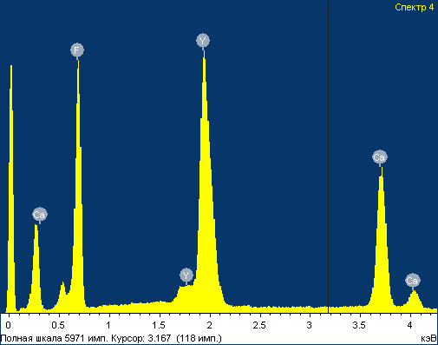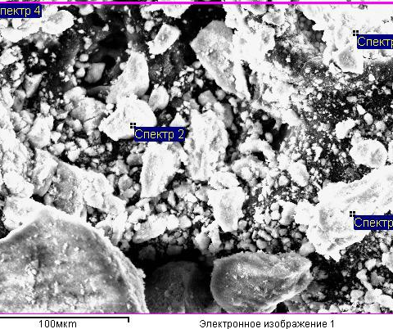
Fig. 1.

Table 4. X-Ray spectroscopy analysis of Ca_{0.1}Y_{0.9}F_{2.9} specimen

Parameters: analysis for all elements
Spectrum | F | Ca | Y
Spectrum 1 | 80.79 | 1.76 | 17.45
Spectrum 2 | 85.19 | 1.42 | 13.40
Spectrum 3 | 82.78 | 1.48 | 15.74
Spectrum 4 | 85.44 | 1.39 | 13.18
Average | 83.55 | 1.51 | 14.94
Standard deviation | 2.20 | 0.17 | 2.04
Max. | 85.44 | 1.76 | 17.45
Min. | 80.79 | 1.39 | 13.18

All results are given in atomic %

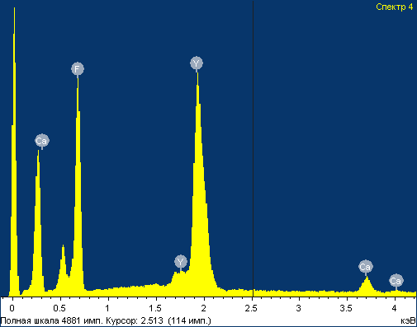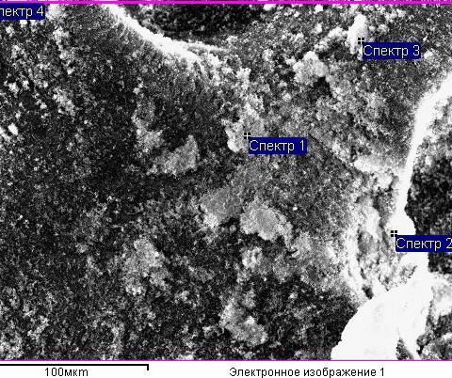
Fig. 2.

Thermal analysis data (MOM Q-1500D Paulik-Paulik-Erdey, Hungary, thermoanalyzer; Pt crucibles; air; 10 K/min heating rate; ca. 300 mg specimens)

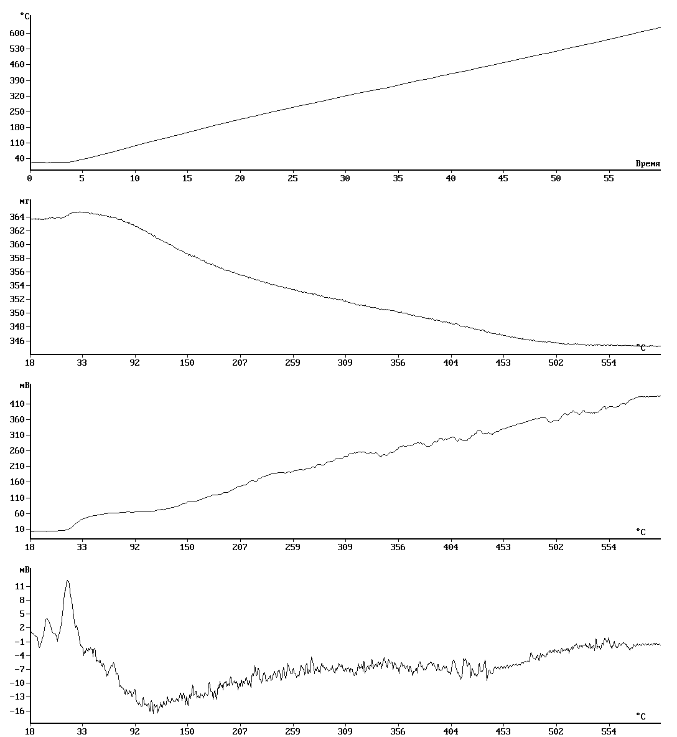

Fig. 3. Thermal analysis data for Ca_{0.9}Y_{0.1}F_{2.1} specimen (mass loss Δm = 5.2 %).

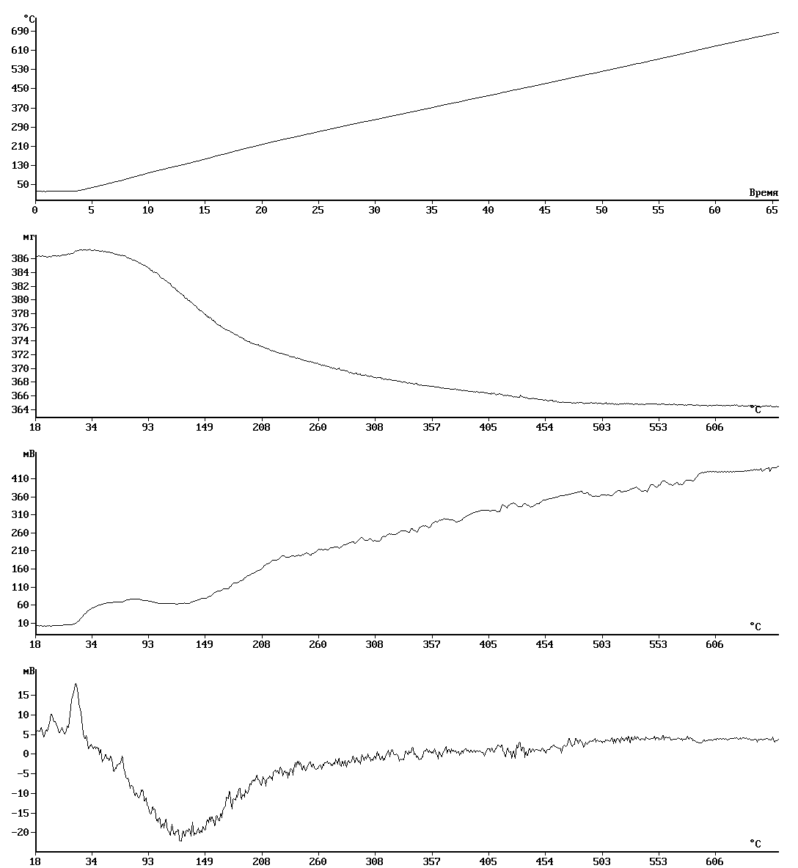

Fig. 4. Thermal analysis data for Ca_{0.5}Y_{0.5}F_{2.5} specimen (mass loss Δm = 5.4 %).
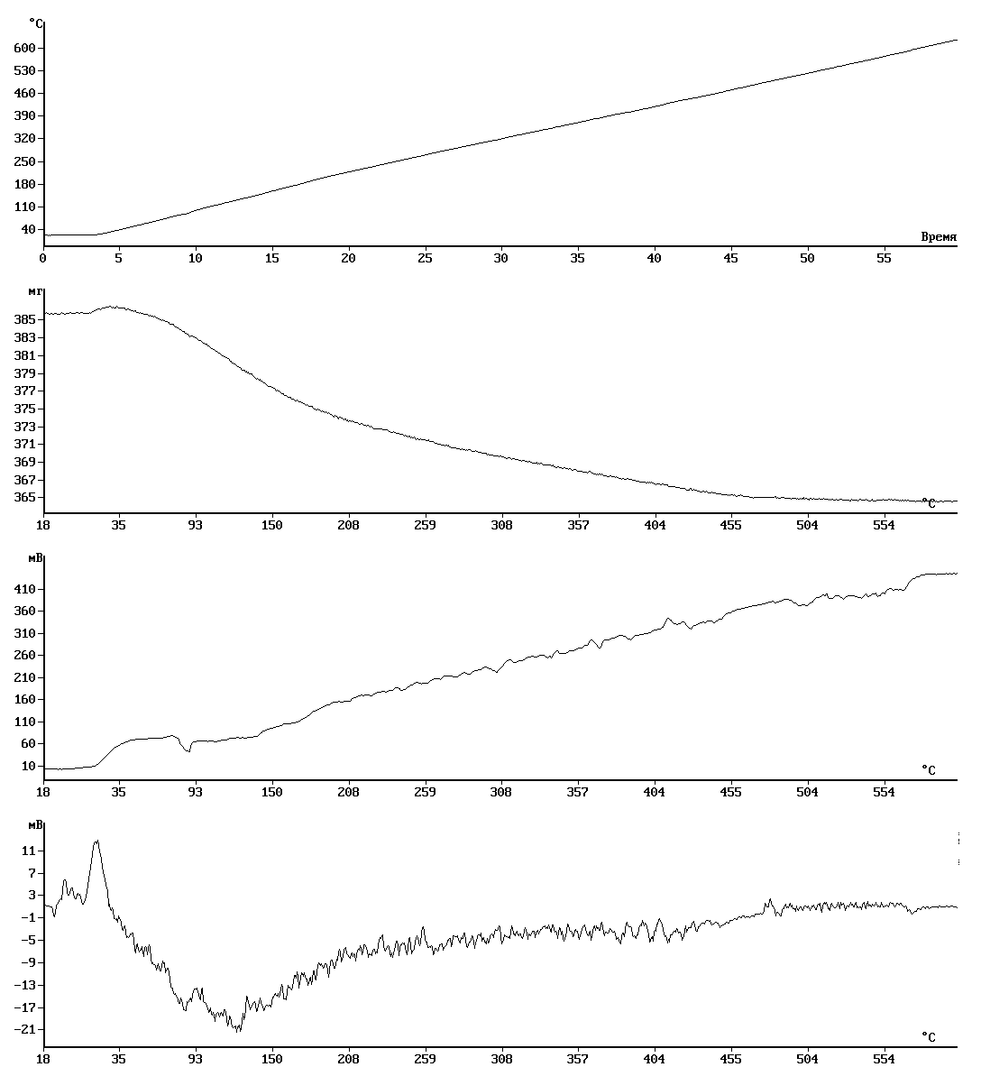

Fig. 5. Thermal analysis data for Ca_{0.3}Y_{0.7}F_{2.7} specimen (mass loss Δm = 5.8 %).
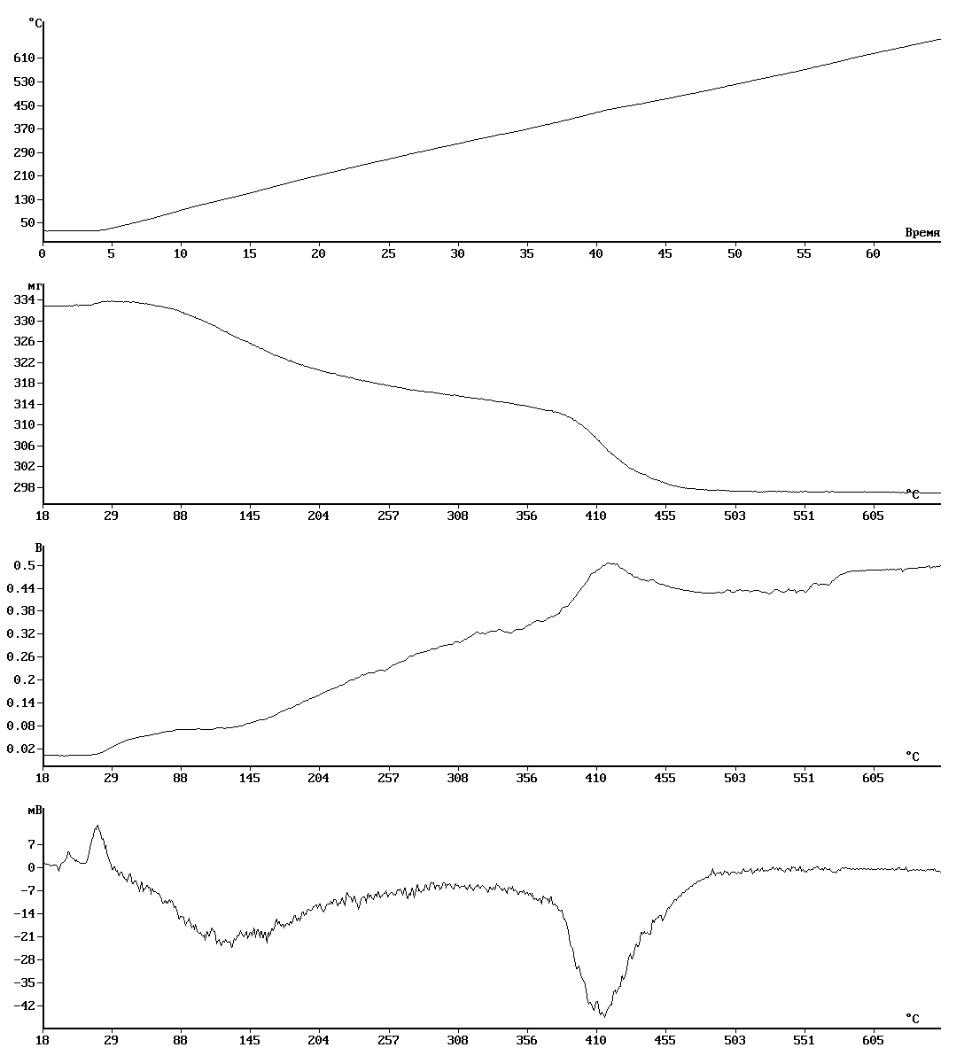

Fig. 6. Thermal analysis data for Ca_{0.1}Y_{0.9}F_{2.9} specimen (mass loss Δm₁ ~ 5.0 %, Δm₂ = 6.3 %, total mass loss = 11.3 %).

X-Ray powder diffraction (Bruker D8 diffractometer; CuK_{α} radiation).
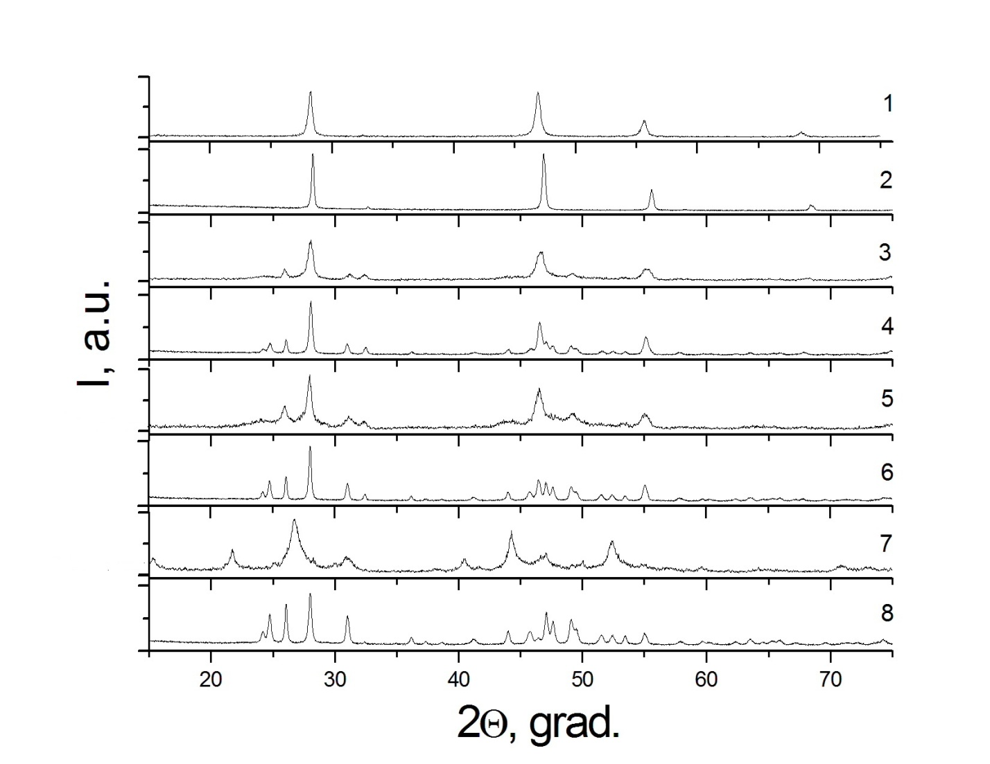
Fig.7. X-Ray diffraction patterns of freshly synthesized and heated under thermal analysis conditions [FORMULA] specimens: 10 mol.% YF₃, freshly synthesized (1); 10 mol.% YF₃, heated (2); 50 mol.% YF₃, freshly synthesized (3); 50 mol.% YF₃, heated (4); 70 mol.% YF₃, freshly synthesized (5); 70 mol.% YF₃, heated (6); 90 mol.% YF₃, freshly synthesized (7); 90 mol.% YF₃, heated (8).

