a | e
b | f
c | g
d | h
Fig. S1. Histograms of particle width (D, nm) distribution: a)Mg(OH)₂; b)0.2; c)0.5; d)0.6. Histograms of particle thickness (h, nm) distribution: e)Mg(OH)₂; f)0.2; g)0.5; h)0.6. Histograms of D and h distribution for Mg(OH)₂ were taken from [9].
a | d
b | e
c | f
Fig. S2. Histograms of particle width (D, nm) distribution: a)0.7; b)0.9; c)1.0. Histograms of particle thickness (h, nm) distribution: a)0.7; b)0.9; s)1.0.

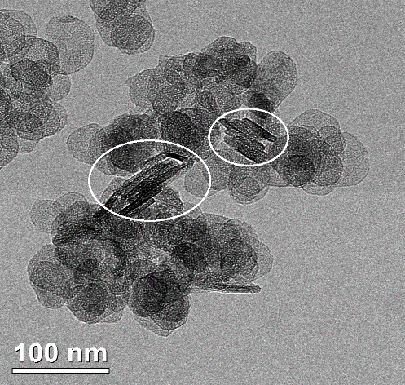 | 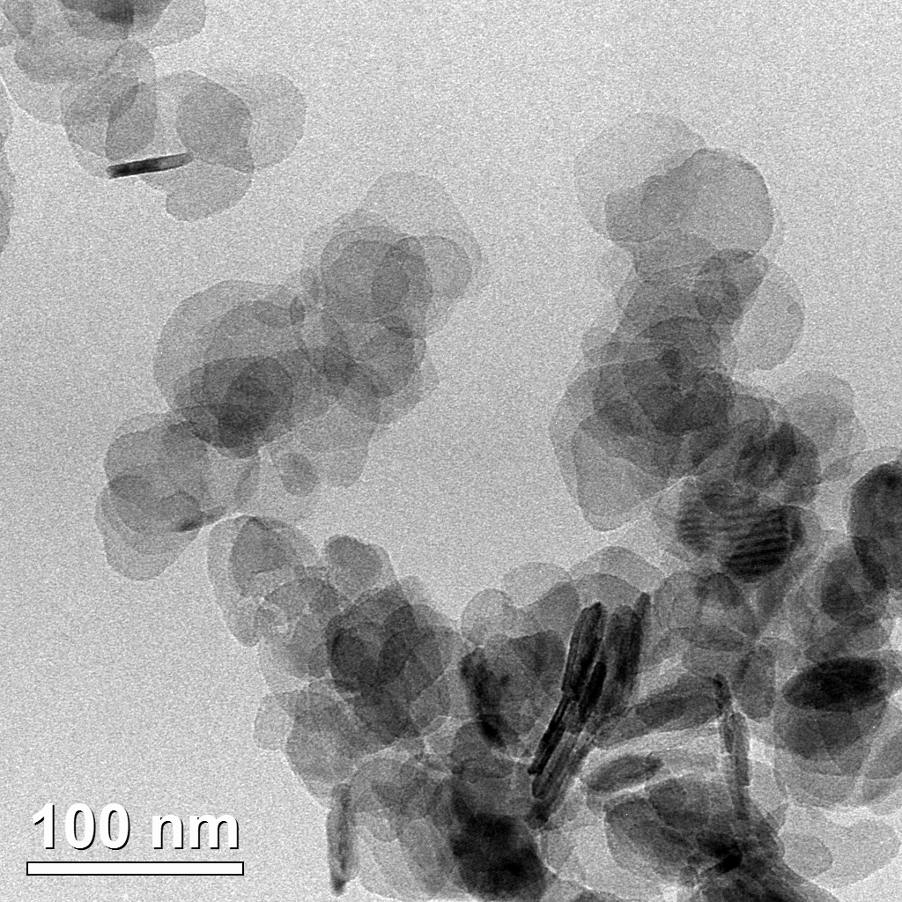 | 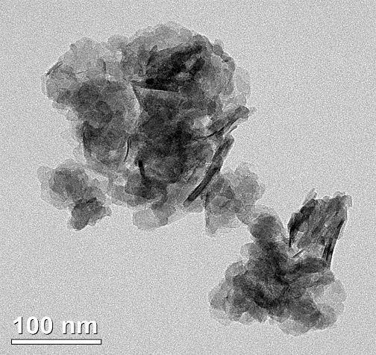
a | b | c
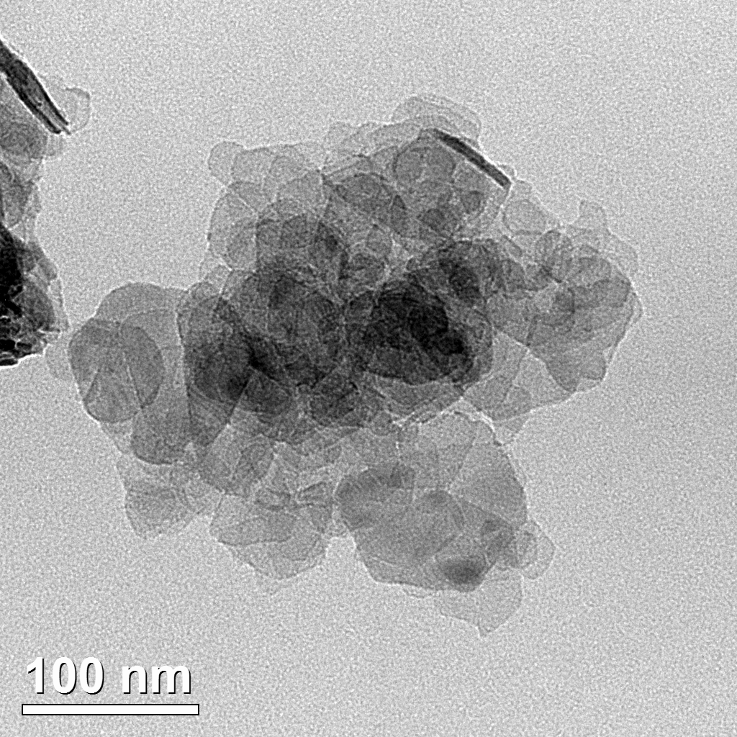 | 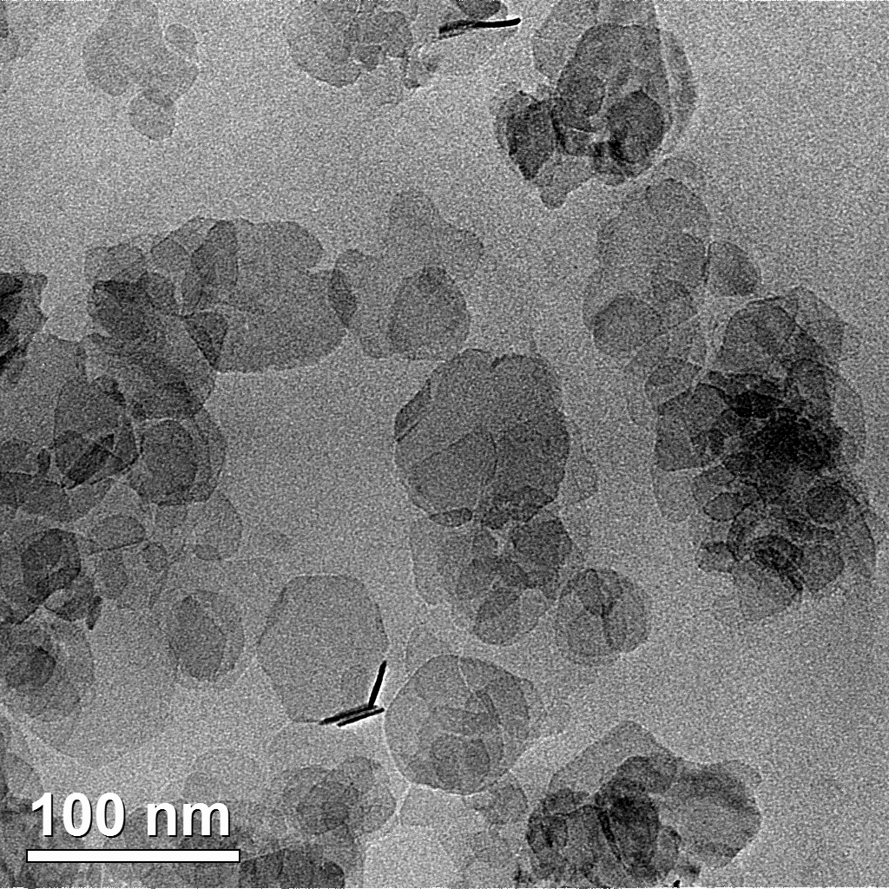 | 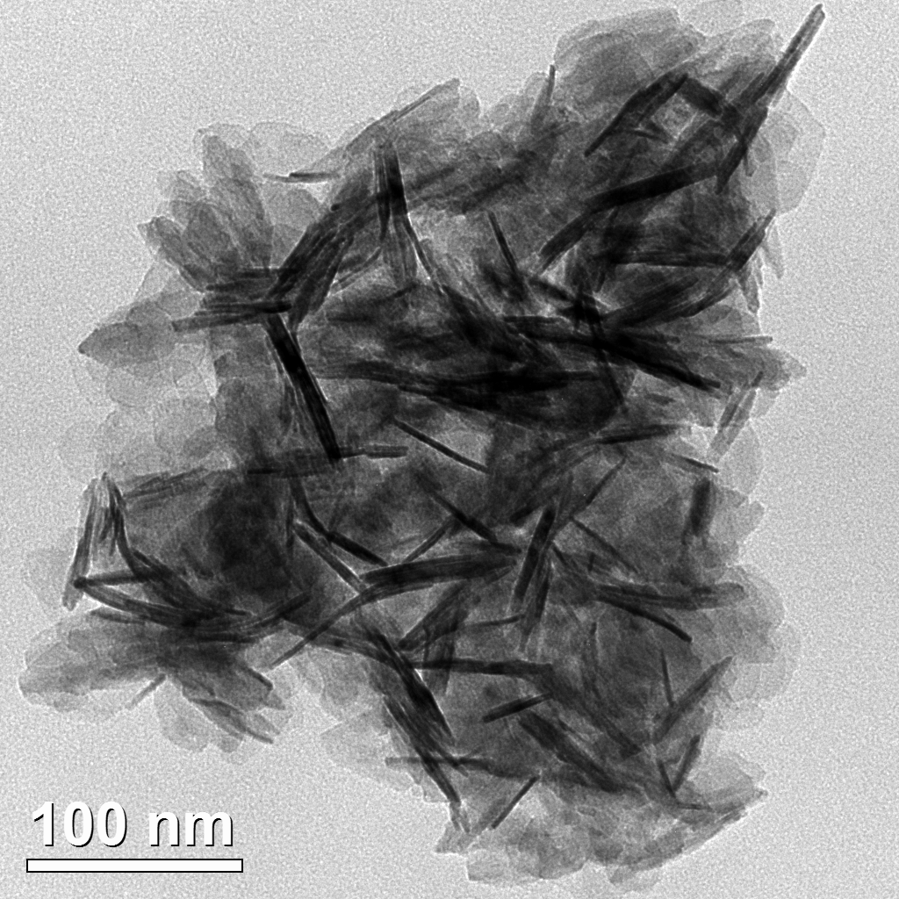
d | e | f
 | 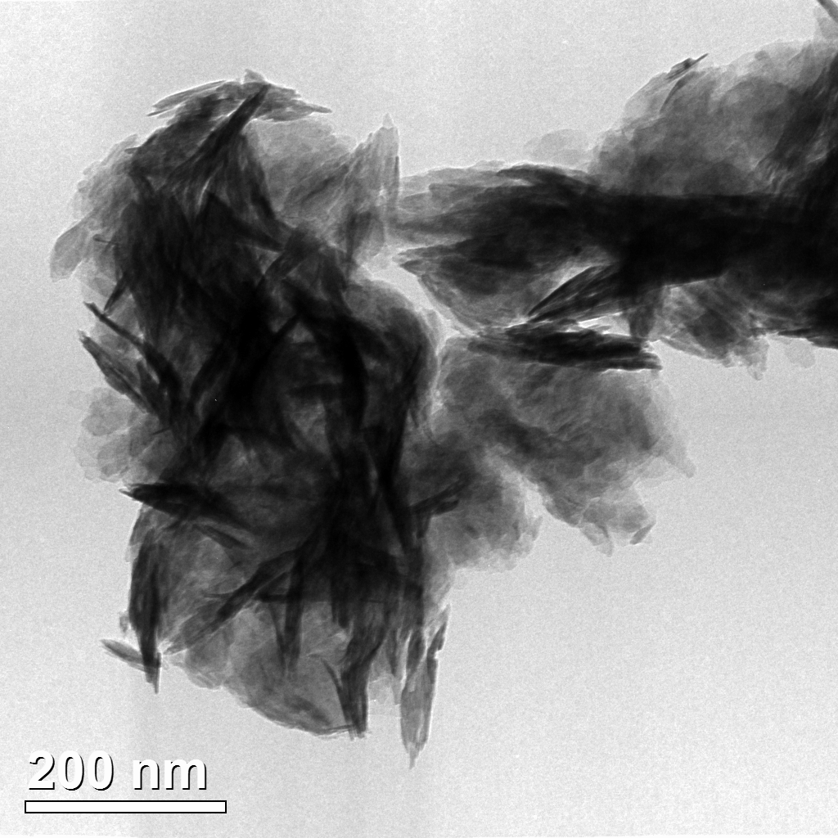
 | g
Fig. S3. Micrographs of hydroxide samples: a) Mg(OH)₂; b) sample 0.2; c) 0.5; d) 0.6; e) 0.7; f) 0.9; g) 1.0. TEM image of Mg(OH)₂ wes taken from [9].

