Supporting Materials
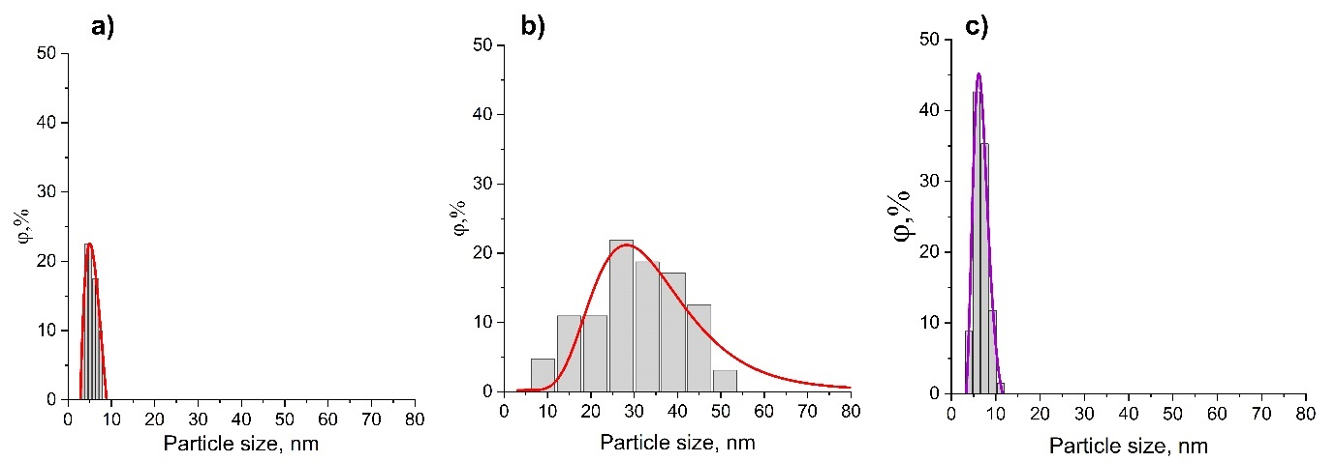
Fig. S1 Histogram of particle size distribution for samples, synthesized by precipitation method: a) Y23% and b) Y73% with rhabdophane structure, c) Y100%(YPO₄) with xenotime structure
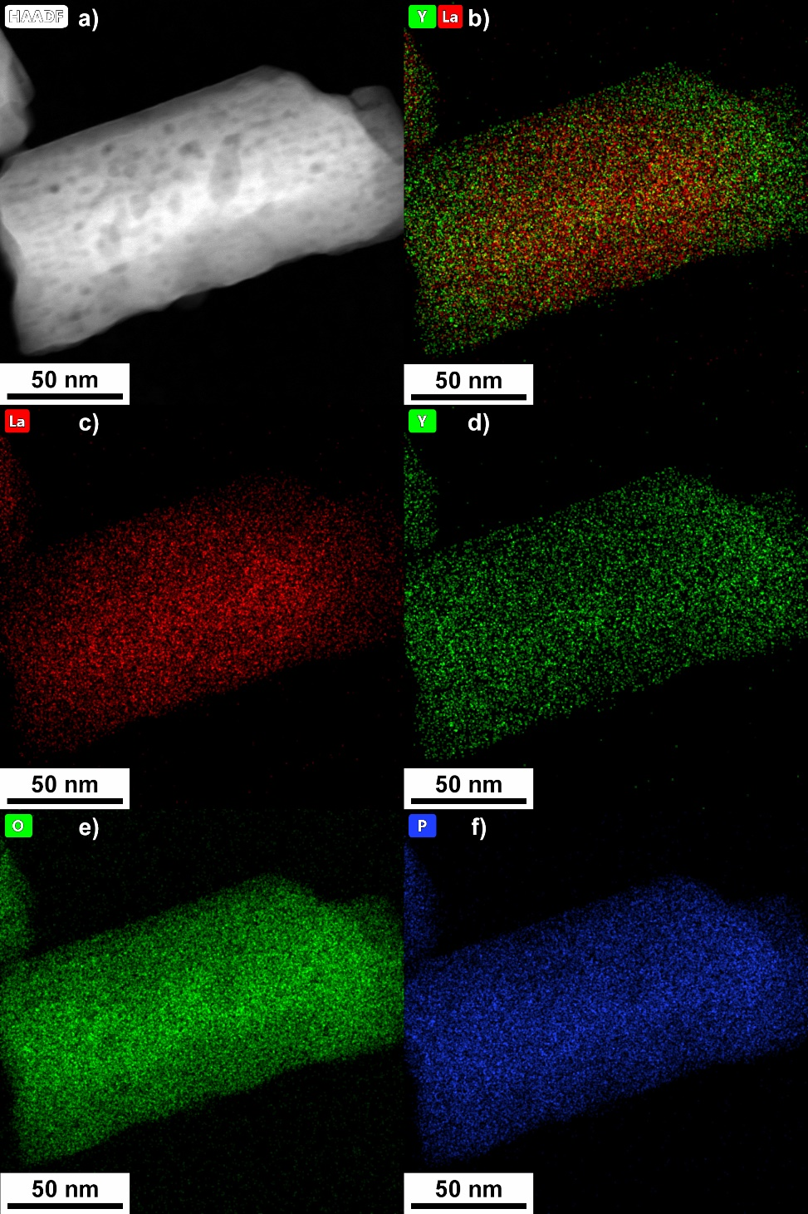
Fig. S2 TEM image (a) and elemental mapping (b-f) particle from the Y73% sample, synthesized by precipitation method

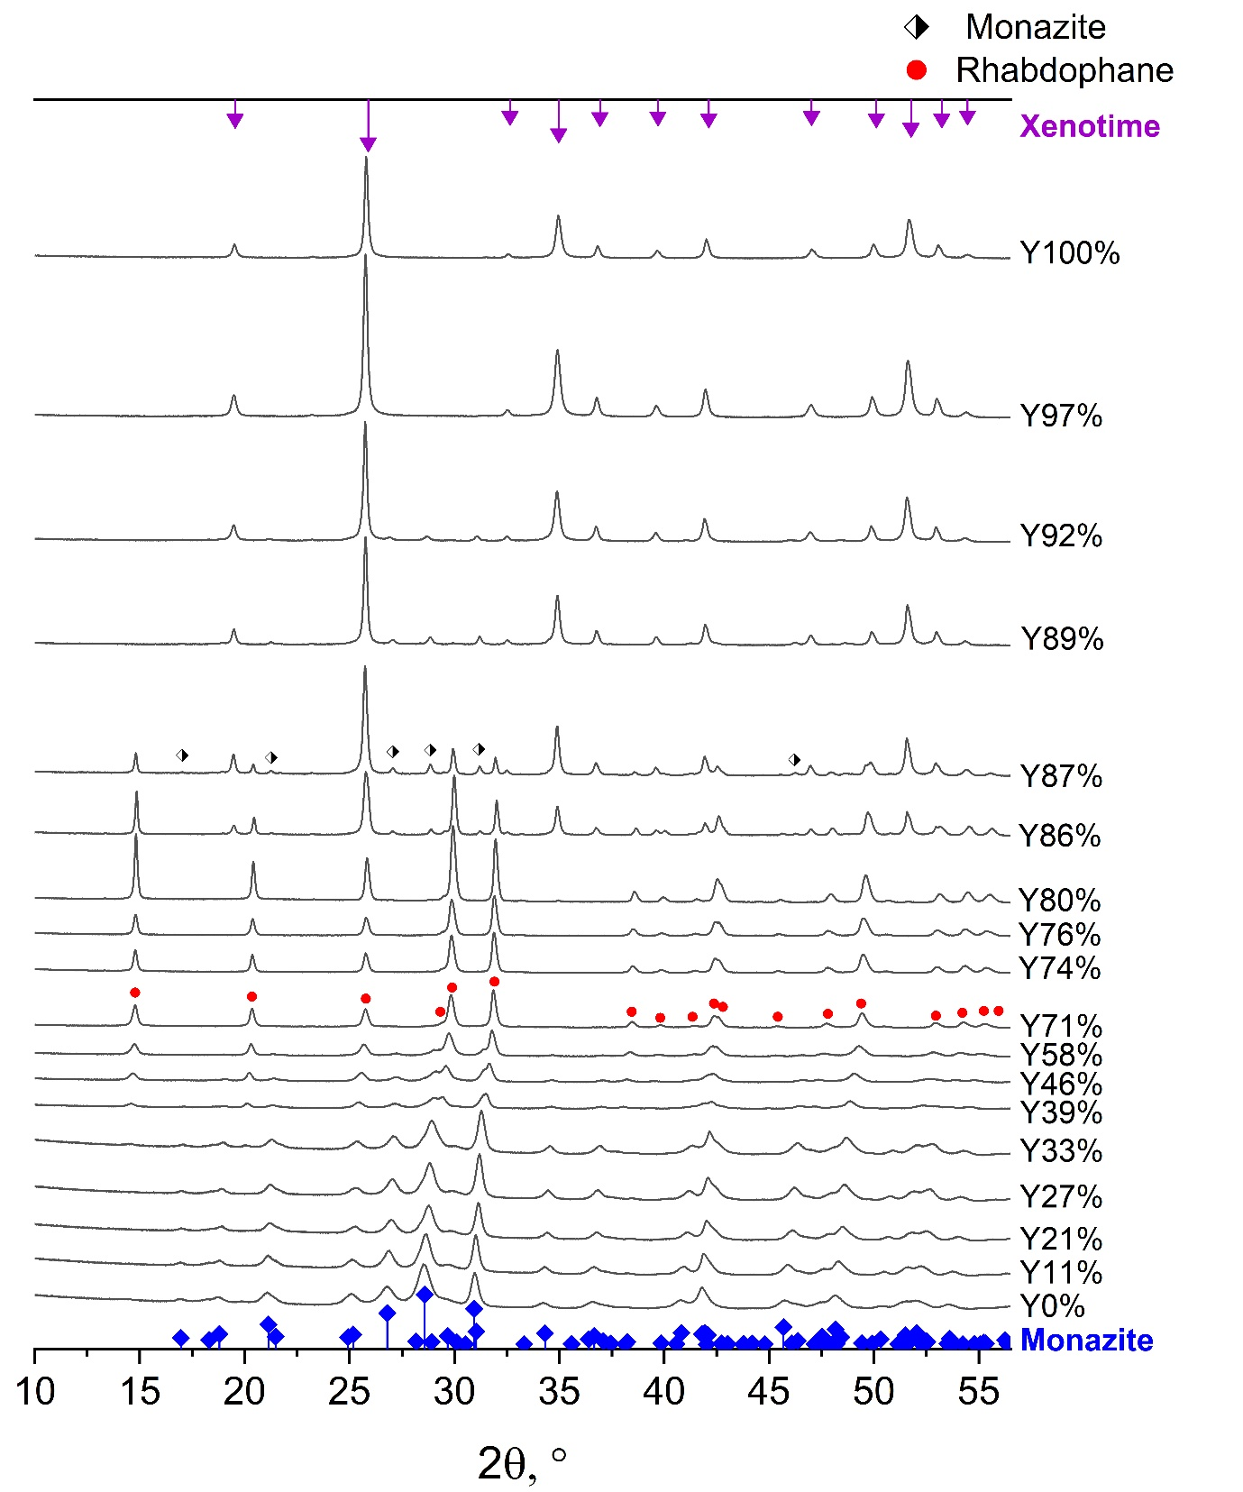
Fig. S3 X-ray diffraction patterns of samples after HT at T=230 °C for 2 hours

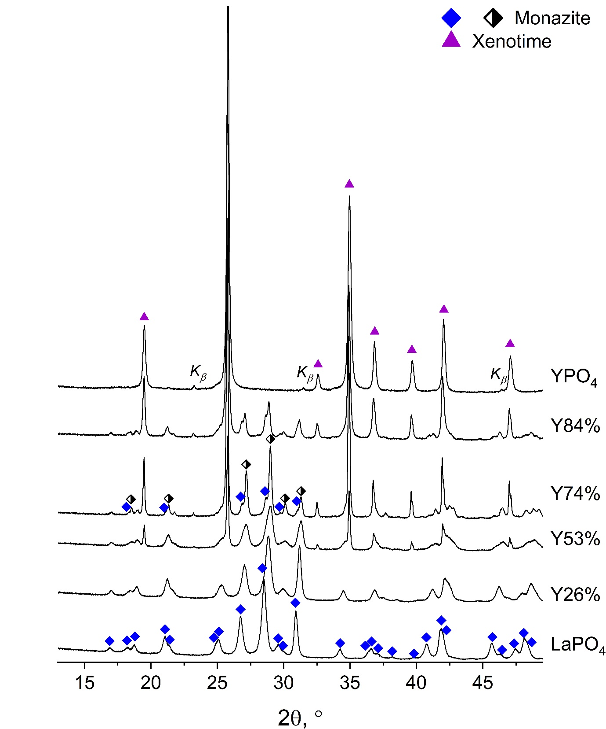
Fig. S4 X-ray diffraction patterns of samples after HT at T=230 °C for 7 days

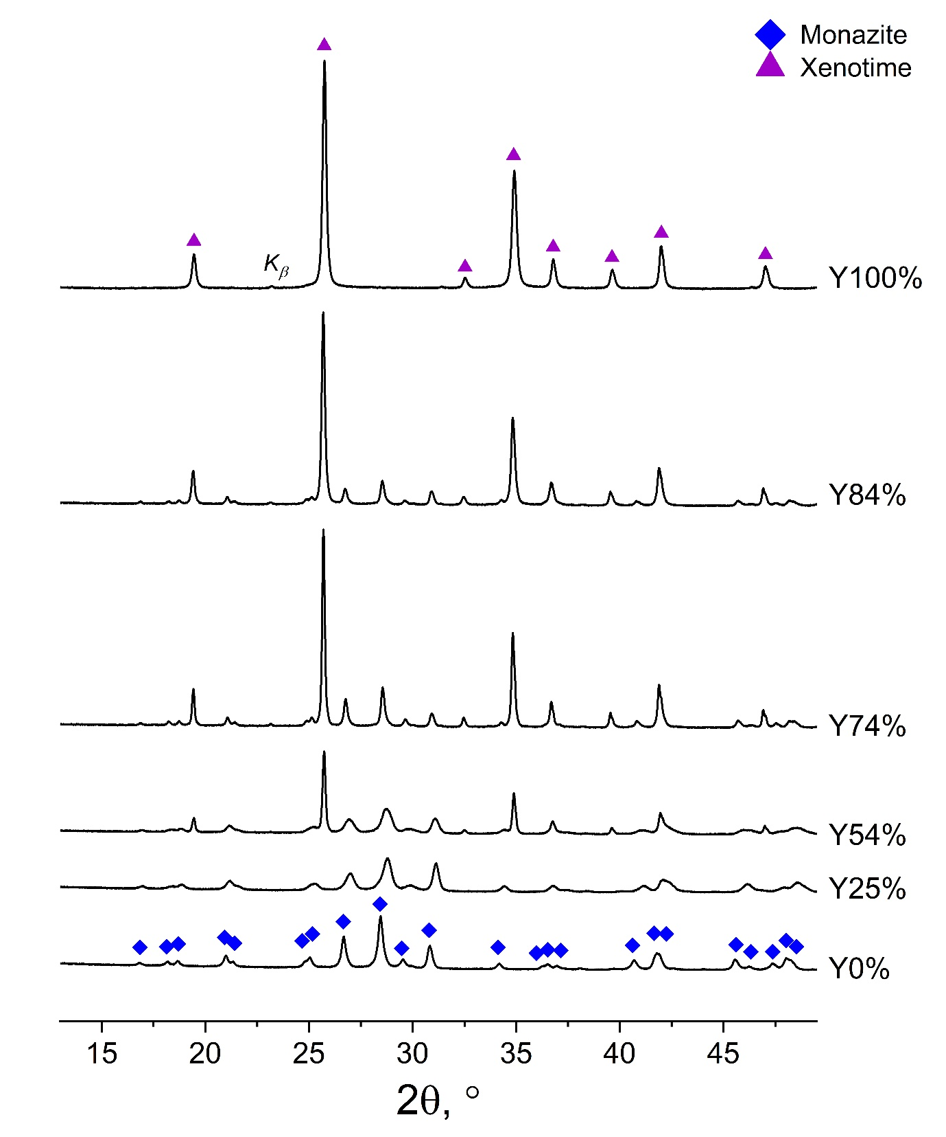
Fig. S5 X-ray diffraction patterns of samples after HT at T=230 °C for 28 days

