Supplementary information
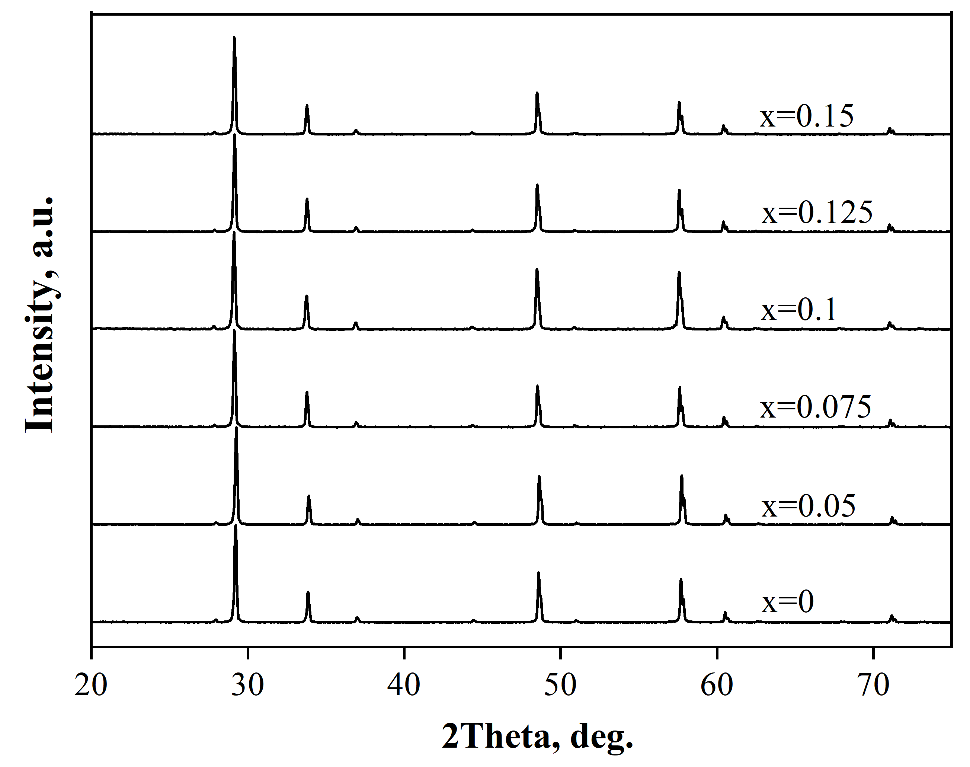
Fig. S1. XRD patterns for Sm_{2-x}Ca_{x}Zr₂O_{7-δ} (x = 0; 0.05; 0.075; 0.1; 0.125; 0.15) powders calcined at 1000ºC for 20 hours in dry air.

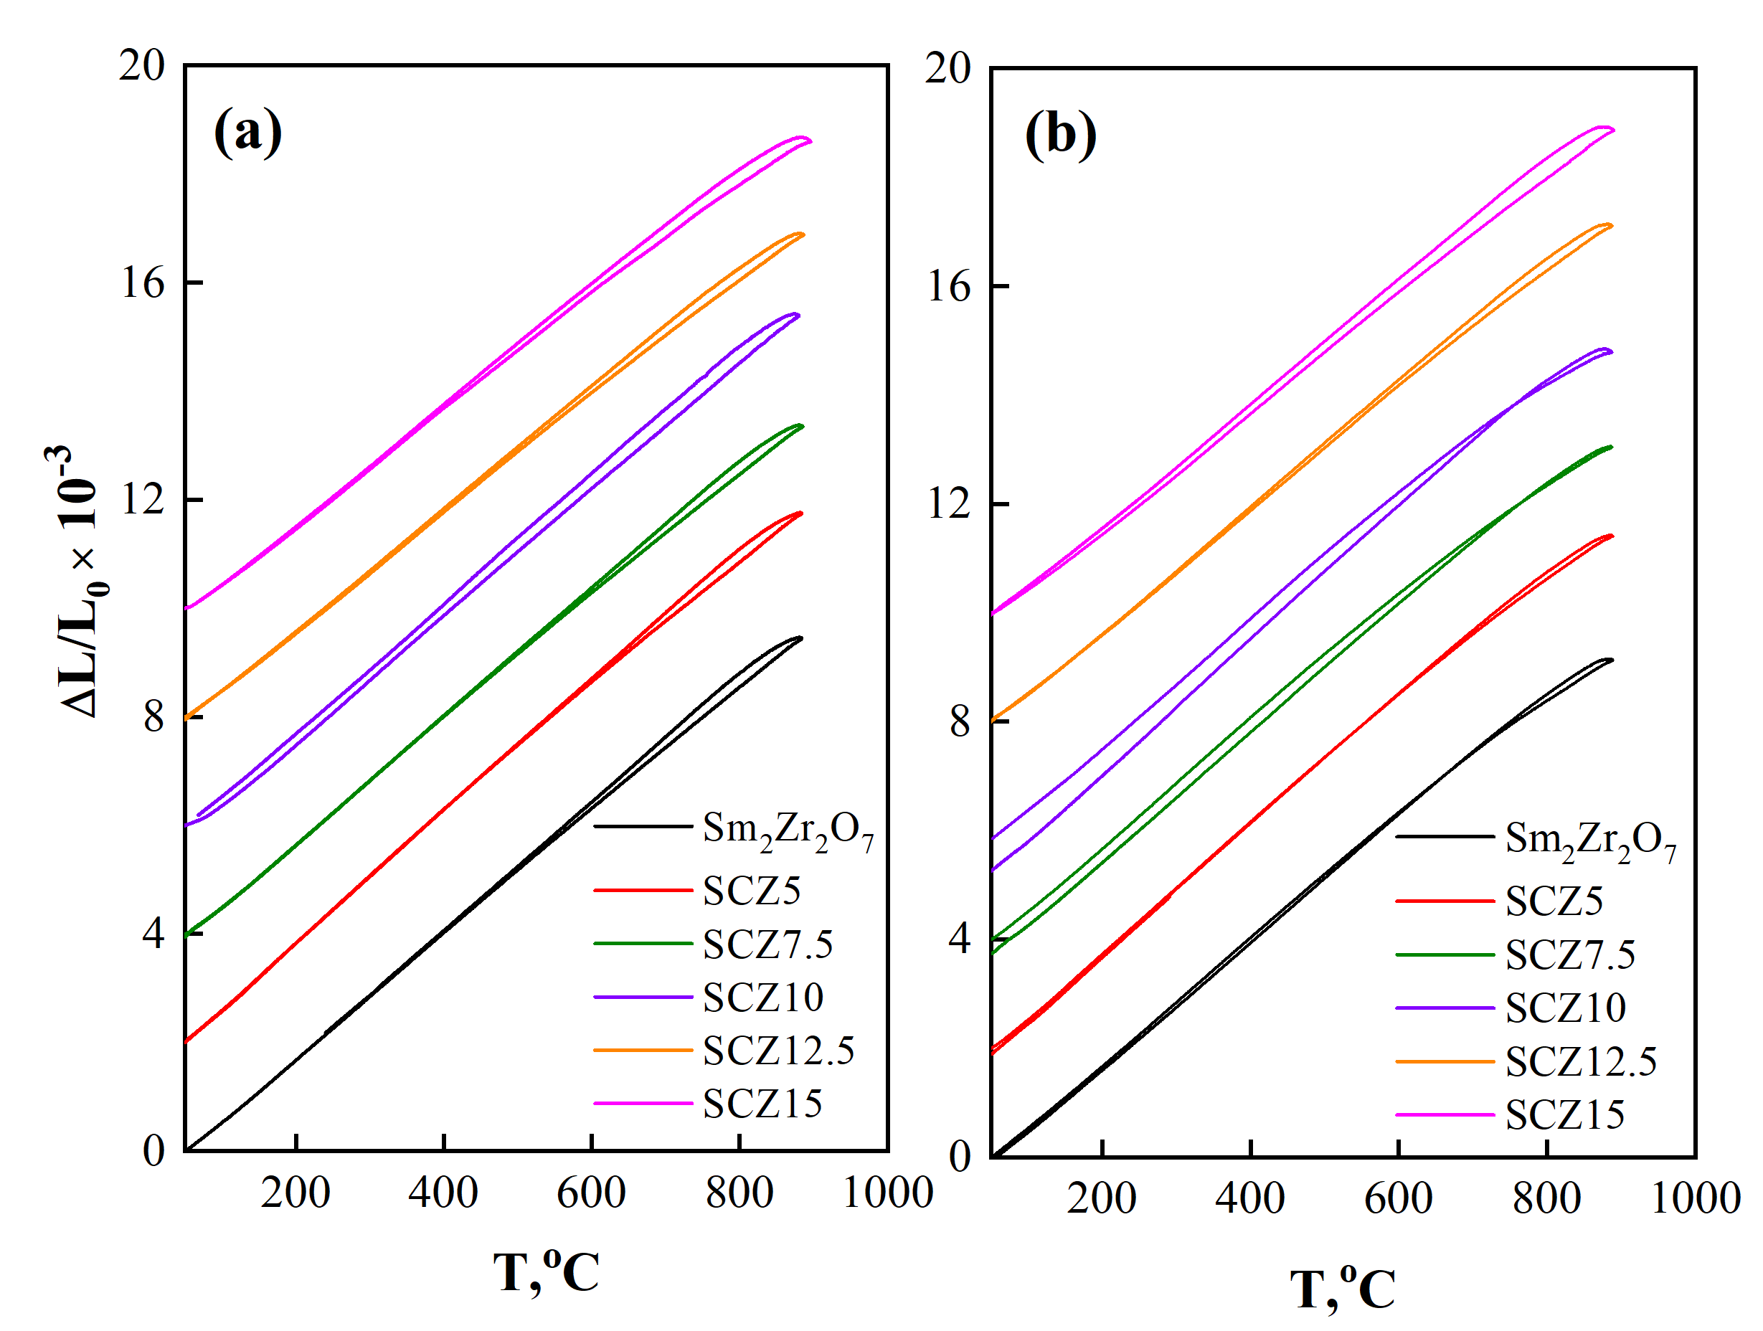
Fig. S2. Temperature dependencies of relative linear expansion and narrowing for Sm_{2-x}Ca_{x}Zr₂O_{7-δ} (x = 0; 0.05; 0.075; 0.1; 0.125; 0.15) dry (a) and wet (b) atmospheres.
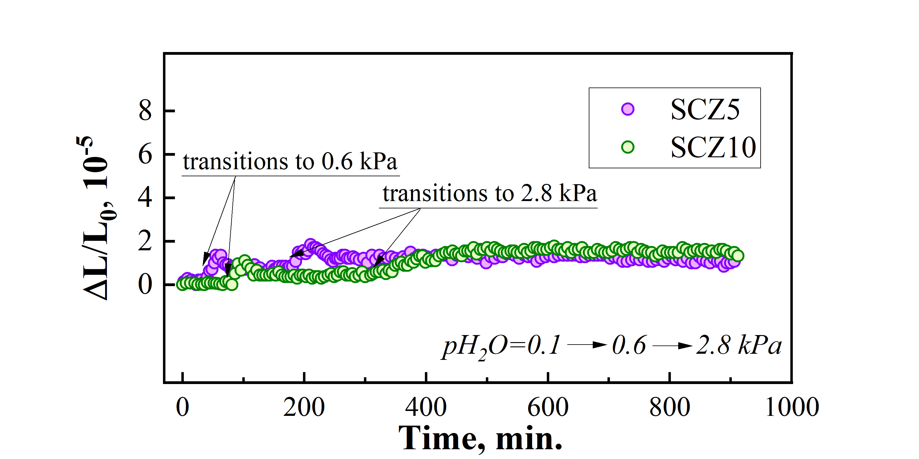
Fig. S3. Сhemical expansion of SCZ5 and SCZ10 samples during the transition from a dry atmosphere (pH₂O≈0.1kPa) to humidified atmospheres (pH₂O=0.6, 2.8kPa) at a constant temperature T=600ºC.

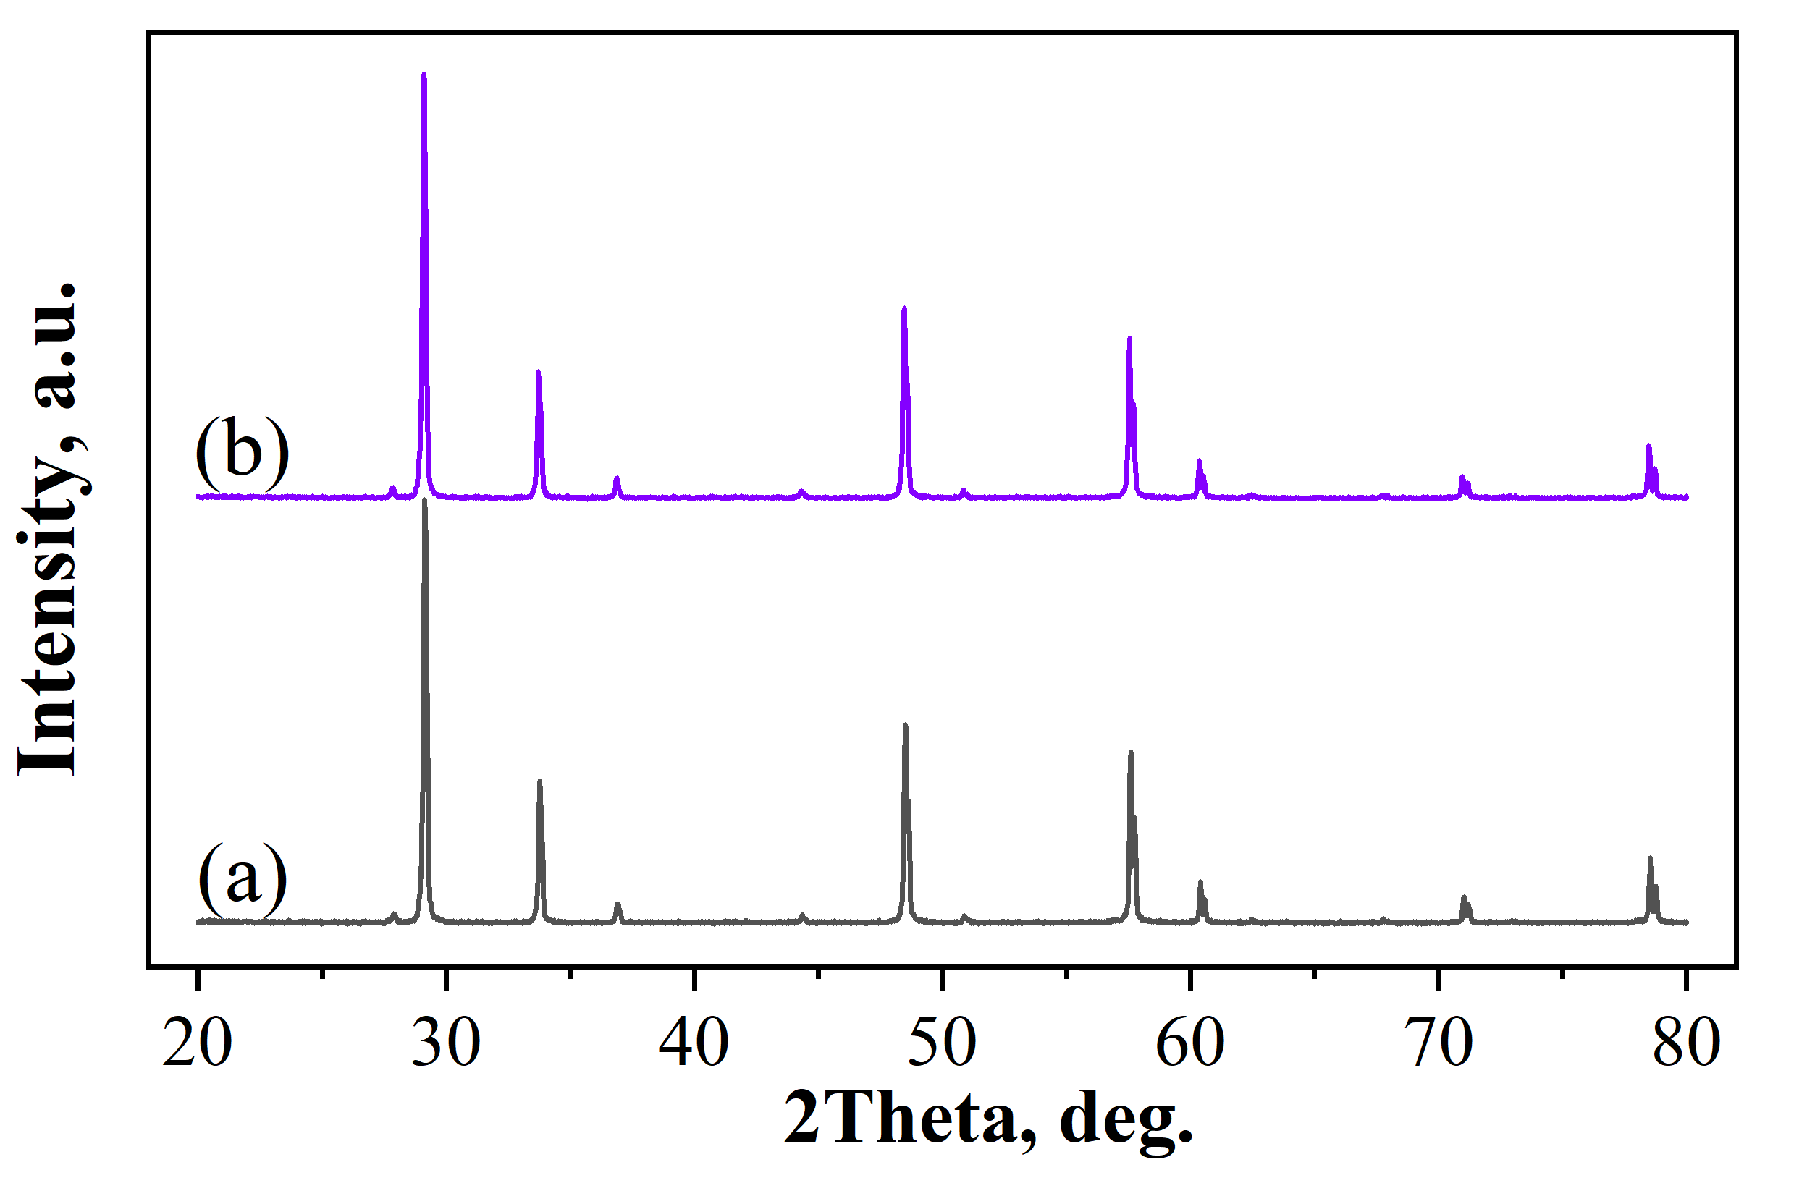
Fig. S4. XRD patterns of the SCZ5 sample before (a) and after (b) exposure in hydrogen (250 hours) at 850ºC

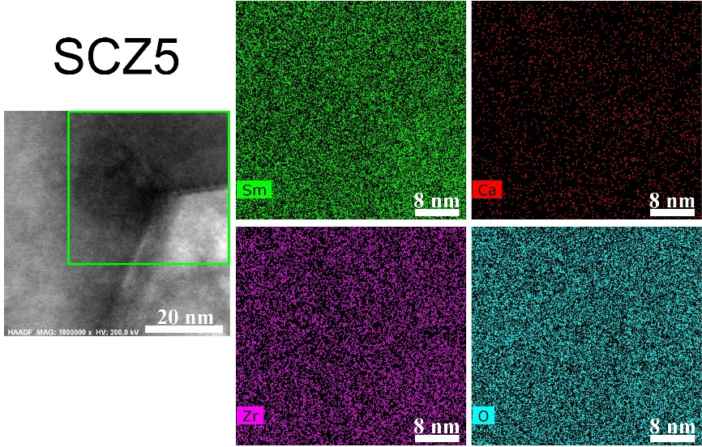
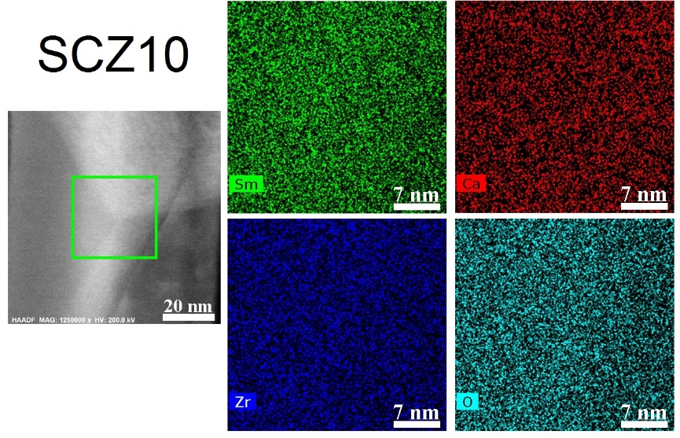
Fig. S5. HAADF and SAED cross-sectional images of SCZ5 and SCZ10 samples in the region of the triple junction of grains with STEM-EDX maps of elements distribution.

