Table S1. Crystal cell parameters a and c, R-factors, and average M-O distances d (M = Fe, Mn) in BaFe_{12-x}Mn_{x}O₁₉, where x = 0, 2, 4, 6 (samples 1, 2 ,3, 4, respectively), annealed at 900, 1000, 1100, 1200 °C (samples’ second symbol a, b, c, d, respectively). Values of a, c, and d are in Å.
Sample | a (Å) | c (Å) | R_{wp}, R_{all} | d(M1-O) | d(M2-O) | d(M3-O) | d(M4-O) | d(M5-O)
1a | 5.8950(1) | 23.2182(3) | 0.031, 0.019 | 2.013(5) | 1.914(9) | 1.887(6) | 2.023(6) | 2.032(4)
1b | 5.8949(1) | 23.2135(2) | 0.029, 0.019 | 2.020(5) | 1.916(7) | 1.883(5) | 2.020(5) | 2.032(3)
1c | 5.8941(1) | 23.2067(2) | 0.036, 0.015 | 2.008(4) | 1.920(6) | 1.888(4) | 2.020(4) | 2.031(3)
1d | 5.8951(1) | 23.2106(2) | 0.038, 0.017 | 2.014(4) | 1.920(6) | 1.887(4) | 2.020(4) | 2.032(3)
2a | 5.8965(1) | 23.1981(3) | 0.031, 0.016 | 2.016(5) | 1.921(8) | 1.913(6) | 2.016(6) | 2.024(3)
2b | 5.8972(1) | 23.1985(3) | 0.028, 0.023 | 2.008(5) | 1.909(9) | 1.914(6) | 2.025(6) | 2.024(4)
2c | 5.8965(1) | 23.1929(2) | 0.035, 0.015 | 2.003(4) | 1.922(6) | 1.914(4) | 2.015(4) | 2.027(3)
2d | 5.8987(1) | 23.1978(2) | 0.039, 0.016 | 2.004(4) | 1.922(6) | 1.920(4) | 2.013(4) | 2.025(3)
3a | 5.9006(1) | 23.1746(3) | 0.028, 0.016 | 2.010(5) | 1.928(7) | 1.936(5) | 2.014(5) | 2.018(4)
3b | 5.9009(1) | 23.1720(3) | 0.028, 0.022 | 2.011(5) | 1.941(8) | 1.939(6) | 2.009(6) | 2.016(4)
3c | 5.9020(1) | 23.1707(2) | 0.030, 0.018 | 2.002(5) | 1.919(7) | 1.945(5) | 2.015(5) | 2.019(3)
3d | 5.9025(1) | 23.1743(2) | 0.042, 0.016 | 1.996(4) | 1.915(6) | 1.953(4) | 2.018(4) | 2.014(3)
4a | 5.9065(1) | 23.1439(3) | 0.027, 0.017 | 1.992(5) | 1.950(7) | 1.961(5) | 2.003(6) | 2.014(4)
4b | 5.9066(1) | 23.1420(3) | 0.028, 0.021 | 1.983(5) | 1.935(8) | 1.967(6) | 2.007(6) | 2.015(4)
4c | 5.9078(1) | 23.1426(3) | 0.029, 0.028 | 1.985(5) | 1.921(8) | 1.981(6) | 2.016(6) | 2.009(4)
4d | 5.9091(1) | 23.1494(2) | 0.042, 0.023 | 1.977(4) | 1.918(6) | 1.980(4) | 2.020(4) | 2.008(3)

Table S2. Atomic parameters in the crystal structure of BaFe₁₂O₁₉ annealed at 1200 °C.
Atom | Occupancy | x/a | y/a | z/c | U_{iso} (Å²)
Ba | 1 | 2/3 | 1/3 | 1/4 | 0.0065(2)
Fe1 | 1 | 0 | 0 | 0 | 0.0048(4)
Fe2 | 0.5 | 0 | 0 | 0.25869(14) | 0.0039(6)
Fe3 | 1 | 1/3 | 2/3 | 0.02733(6) | 0.0045(3)
Fe4 | 1 | 1/3 | 2/3 | 0.19032(5) | 0.0047(3)
Fe5 | 1 | 0.16853(9) | 0.33706(19) | 0.89168(3) | 0.0048(2)
O1 | 1 | 0 | 0 | 0.1492(2) | 0.0063(4)
O2 | 1 | 2/3 | 1/3 | 0.0540(2) | 0.0063(4)
O3 | 1 | 0.1799(5) | 0.3597(11) | 1/4 | 0.0063(4)
O4 | 1 | 0.1575(4) | 0.3150(8) | 0.05221(12) | 0.0063(4)
O5 | 1 | 0.5002(4) | 0.0003(8) | 0.14964(13) | 0.0063(4)

Table S3. Atomic parameters in the crystal structure of BaFe₆Mn₆O₁₉ annealed at 1200 °C.
Atom | Occupancy | x/a | y/a | z/c | U_{iso} (Å²)
Ba | 1 | 2/3 | 1/3 | 1/4 | 0.0093(2)
M1 | 1 | 0 | 0 | 0 | 0.0095(5)
M2 | 0.5 | 0 | 0 | 0.25908(14) | 0.0022(7)
M3 | 1 | 1/3 | 2/3 | 0.02768(7) | 0.0103(3)
M4 | 1 | 1/3 | 2/3 | 0.19062(6) | 0.0069(3)
M5 | 1 | 0.16737(11) | 0.3347(2) | 0.89196(3) | 0.0082(2)
O1 | 1 | 0 | 0 | 0.1514(3) | 0.0154(5)
O2 | 1 | 2/3 | 1/3 | 0.0587(2) | 0.0154(5)
O3 | 1 | 0.1813(6) | 0.3626(12) | 1/4 | 0.0154(5)
O4 | 1 | 0.1499(4) | 0.2998(8) | 0.05387(14) | 0.0154(5)
O5 | 1 | 0.5012(4) | 0.0023(9) | 0.14962(16) | 0.0154(5)

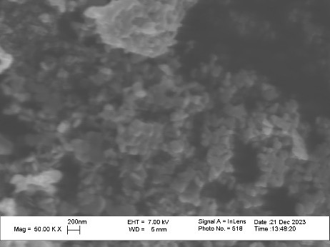  x = 0, T_{an} = 900 °C | 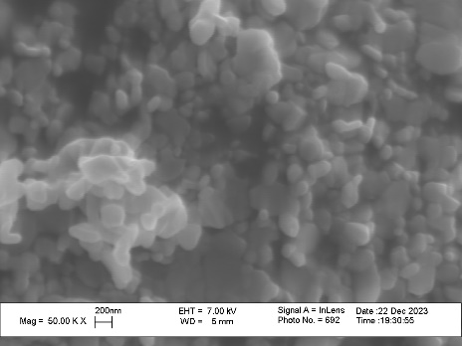  x = 0, T_{an} = 1100 °C | x = 0, T_{an} = 1200 °C
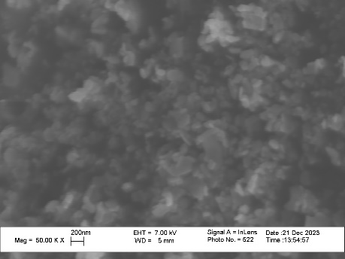  x = 2, T_{an} = 900 °C | 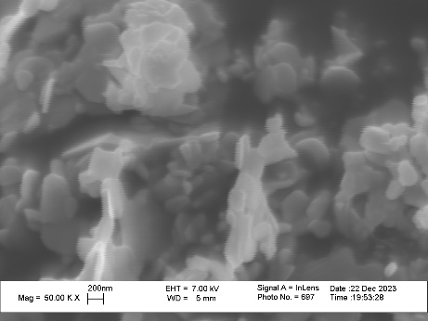  x = 2, T_{an} = 1100 °C | 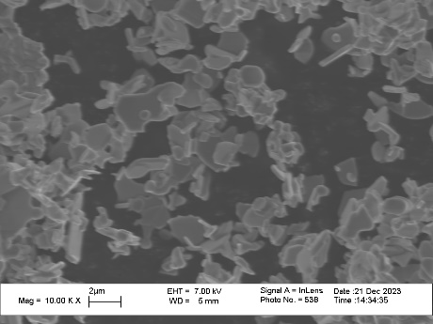  x = 2, T_{an} = 1200 °C
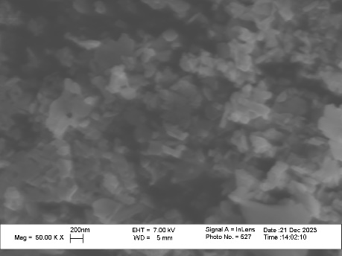  x = 4, T_{an} = 900 °C | 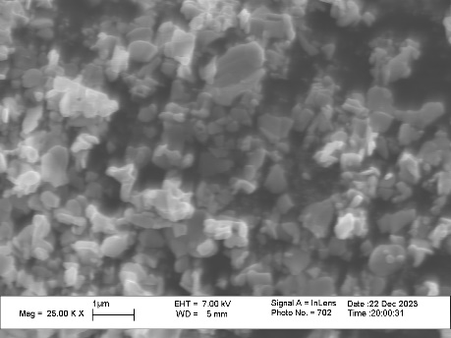  x = 4, T_{an} = 1100 °C | 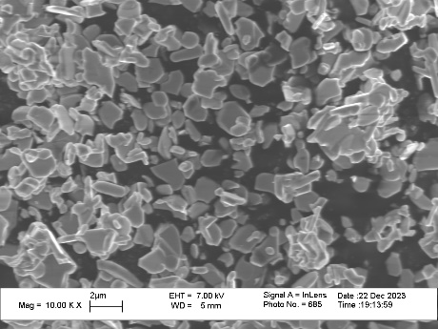  x = 4, T_{an} = 1200 °C
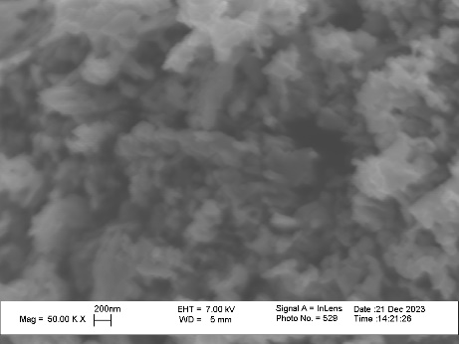  x = 6, T_{an} = 900 °C | 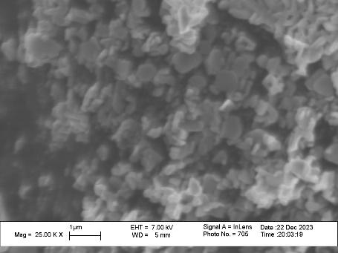  x = 6, T_{an} = 1100 °C | 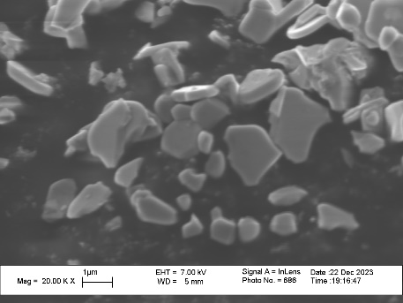  x = 6, T_{an} = 1200 °C

Fig. S1. Scanning electron microscopy images of BaFe_{12-x}Mn_{x}O₁₉ samples annealed at T_{an}.

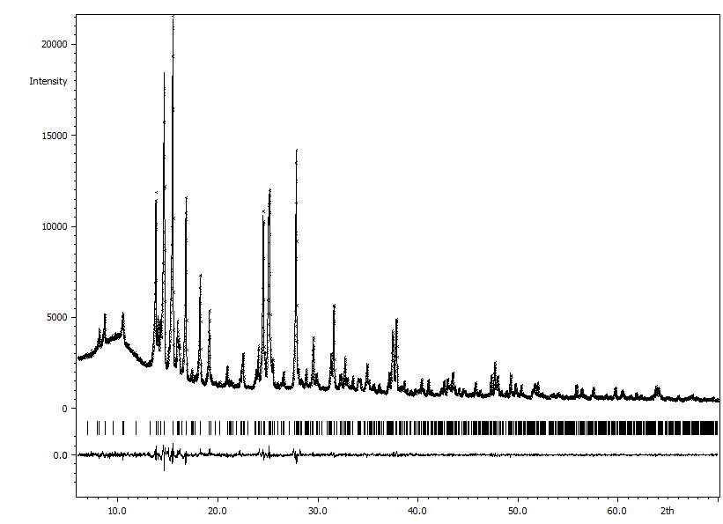
Fig. S2. Observed (crosses), calculated (line), and difference (line underneath) XRD patterns of BaFe_{12-x}Mn_{x}O₁₉, x = 0, T_{an} = 900 °C.

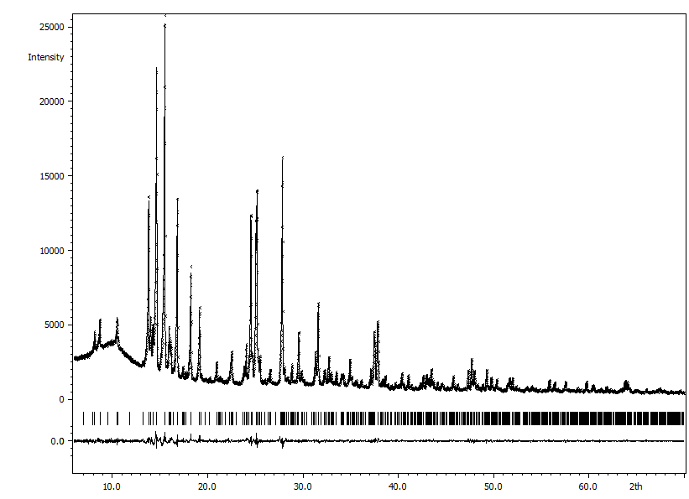
Fig. S3. Observed (crosses), calculated (line), and difference (line underneath) XRD patterns of BaFe_{12-x}Mn_{x}O₁₉, x = 0, T_{an} = 1000 °C.
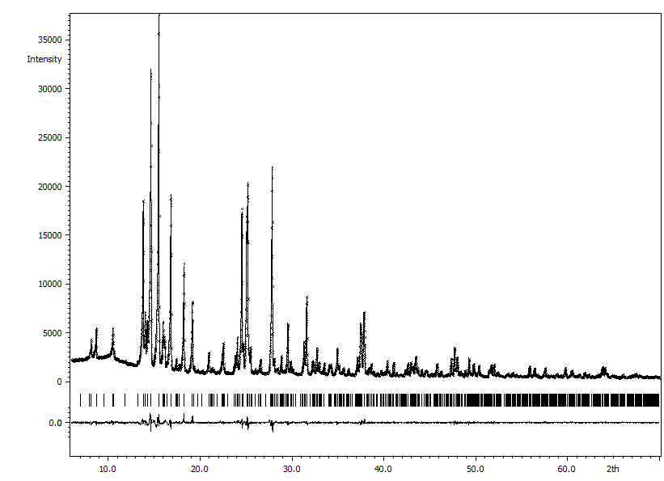
Fig. S4. Observed (crosses), calculated (line), and difference (line underneath) XRD patterns of BaFe_{12-x}Mn_{x}O₁₉, x = 0, T_{an} = 1100 °C.

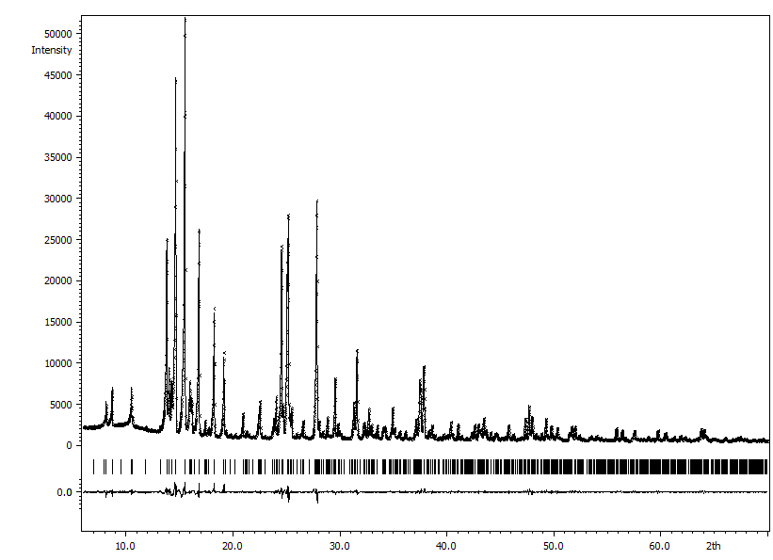
Fig. S5. Observed (crosses), calculated (line), and difference (line underneath) XRD patterns of BaFe_{12-x}Mn_{x}O₁₉, x = 0, T_{an} = 1200 °C.
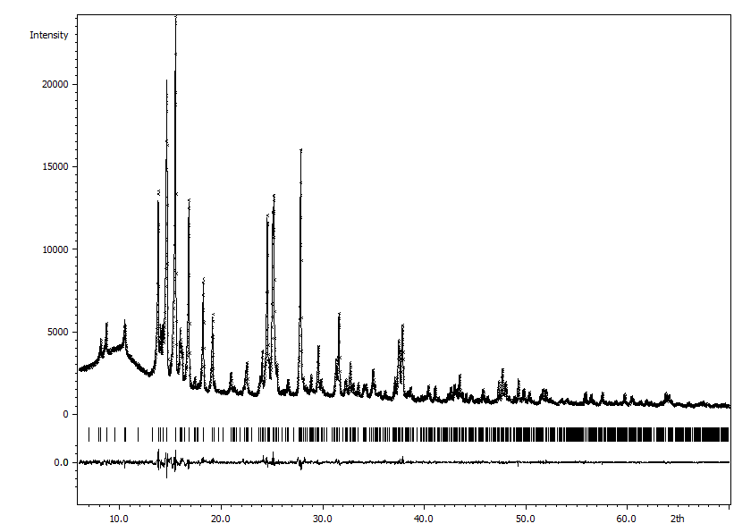
Fig. S6. Observed (crosses), calculated (line), and difference (line underneath) XRD patterns of BaFe_{12-x}Mn_{x}O₁₉, x = 2, T_{an} = 900 °C.

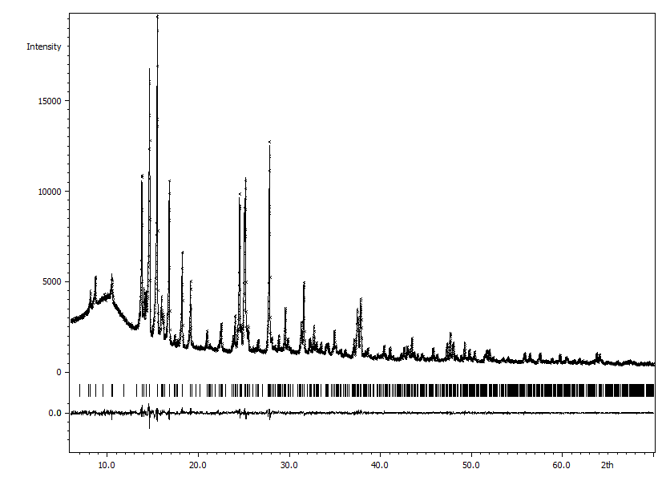
Fig. S7. Observed (crosses), calculated (line), and difference (line underneath) XRD patterns of BaFe_{12-x}Mn_{x}O₁₉, x = 2, T_{an} = 1000 °C.
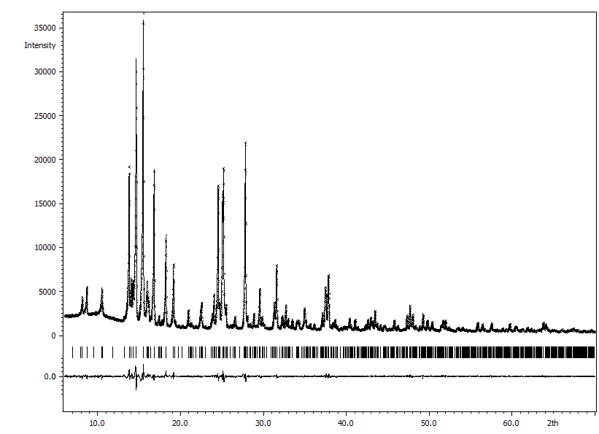
Fig. S8. Observed (crosses), calculated (line), and difference (line underneath) XRD patterns of BaFe_{12-x}Mn_{x}O₁₉, x = 2, T_{an} = 1100 °C.

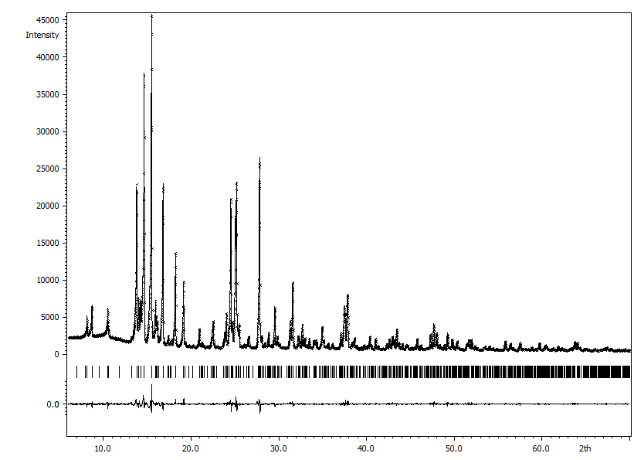
Fig. S9. Observed (crosses), calculated (line), and difference (line underneath) XRD patterns of BaFe_{12-x}Mn_{x}O₁₉, x = 2, T_{an} = 1200 °C.
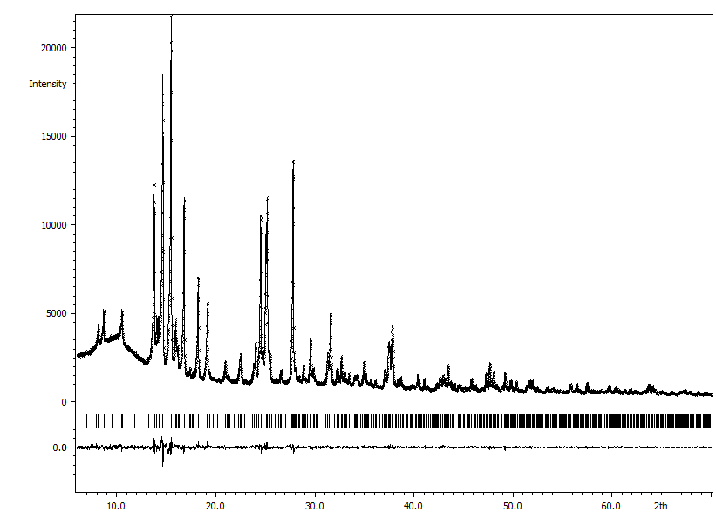
Fig. S10. Observed (crosses), calculated (line), and difference (line underneath) XRD patterns of BaFe_{12-x}Mn_{x}O₁₉, x = 4, T_{an} = 900 °C.

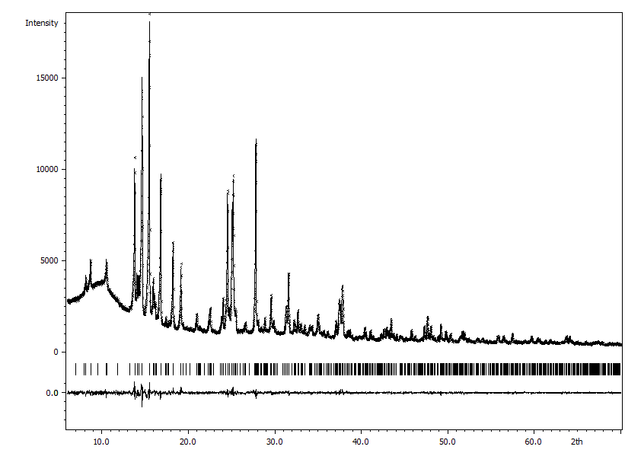
Fig. S11. Observed (crosses), calculated (line), and difference (line underneath) XRD patterns of BaFe_{12-x}Mn_{x}O₁₉, x = 4, T_{an} = 1000 °C.
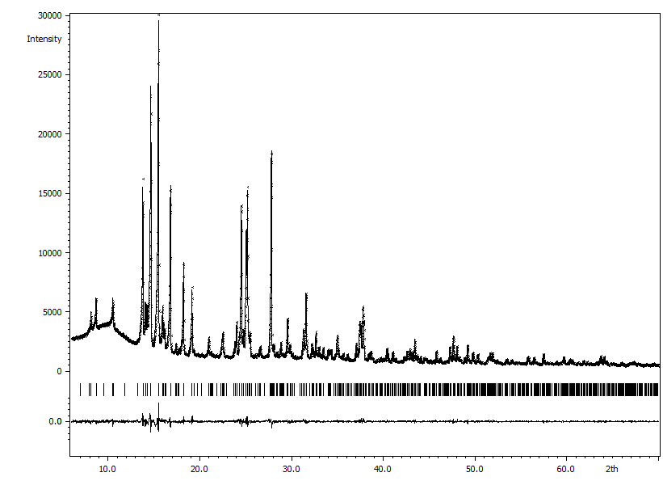
Fig. S12. Observed (crosses), calculated (line), and difference (line underneath) XRD patterns of BaFe_{12-x}Mn_{x}O₁₉, x = 4, T_{an} = 1100 °C.

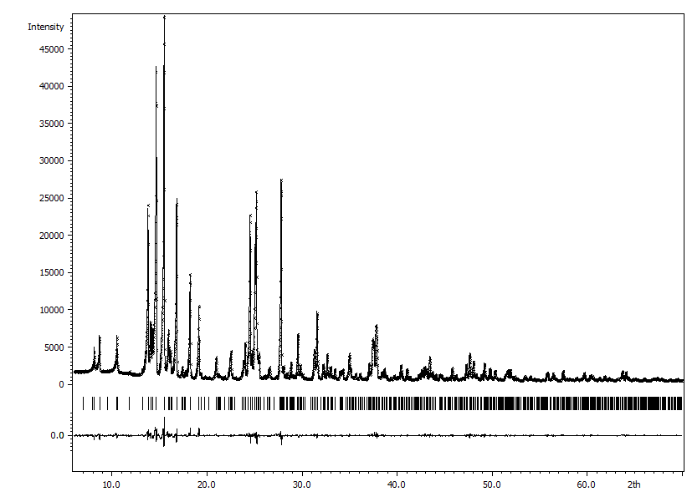
Fig. S13. Observed (crosses), calculated (line), and difference (line underneath) XRD patterns of BaFe_{12-x}Mn_{x}O₁₉, x = 4, T_{an} = 1200 °C.
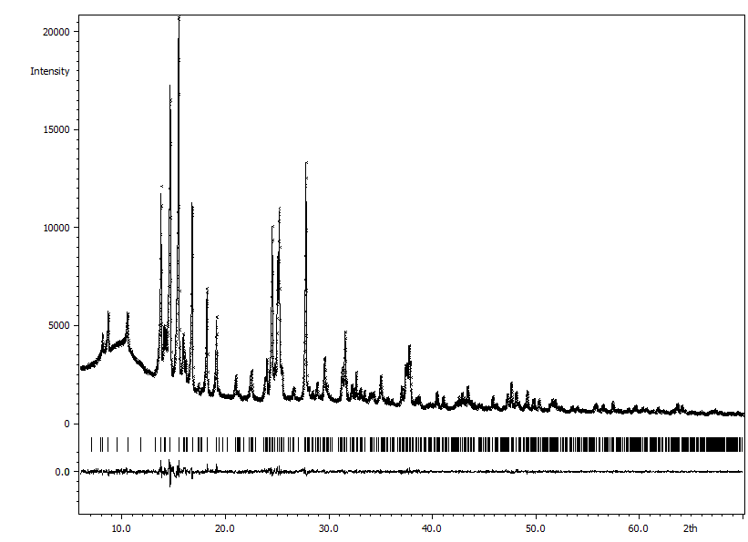
Fig. S14. Observed (crosses), calculated (line), and difference (line underneath) XRD patterns of BaFe_{12-x}Mn_{x}O₁₉, x = 6, T_{an} = 900 °C.

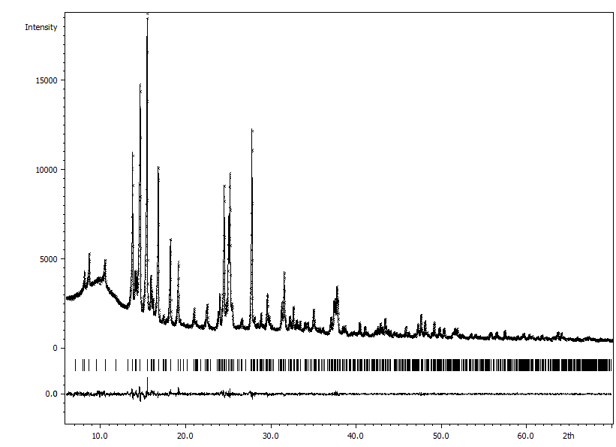
Fig. S15. Observed (crosses), calculated (line), and difference (line underneath) XRD patterns of BaFe_{12-x}Mn_{x}O₁₉, x = 6, T_{an} = 1000 °C.
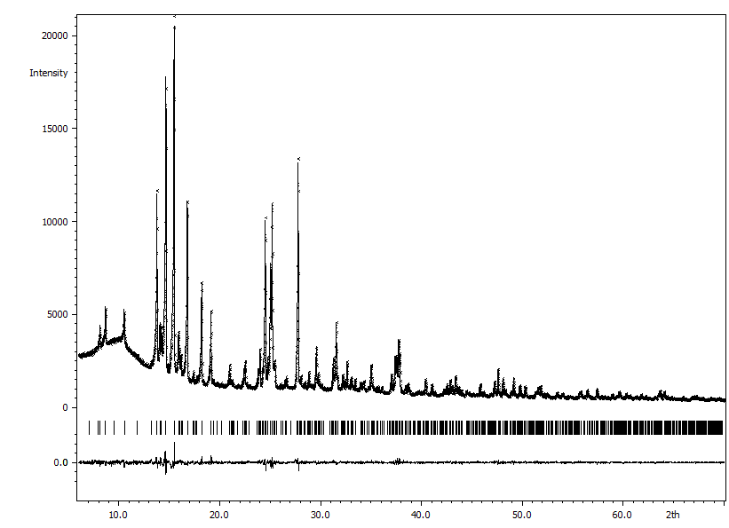
Fig. S16. Observed (crosses), calculated (line), and difference (line underneath) XRD patterns of BaFe_{12-x}Mn_{x}O₁₉, x = 6, T_{an} = 1100 °C.

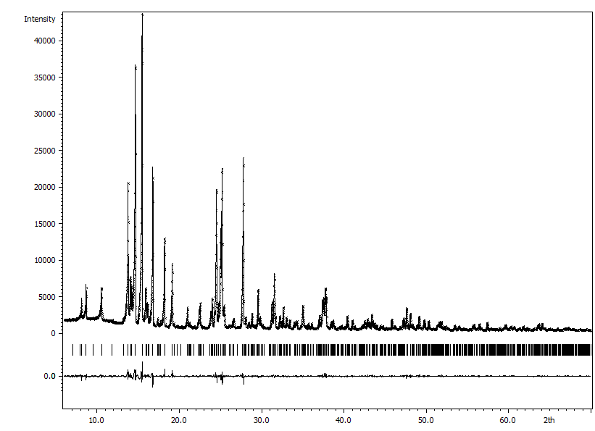
Fig. S17. Observed (crosses), calculated (line), and difference (line underneath) XRD patterns of BaFe_{12-x}Mn_{x}O₁₉, x = 6, T_{an} = 1200 °C.

