Electronic supplementary materials

## SYNTHESIS, STRUCTURE AND NONCOVALENT INTERACTIONS OF MESITYL(PHENYL)PHOSPHINE OXIDE GLYCOLATE BASED HYDROGEN-BONDED NANOSIZED ORGANIC FRAMEWORK

## A.A. Kagilev1, I.F. Sakhapov1, Z.N. Gafurov1, A.O. Kantyukov1,2, I.K. Mikhailov1, D.R. Islamov3, A.V. Gerasimov2, O.A. Filippov4, A.T. Gubaidullin1, O.S. Soficheva1, O.G. Sinayshin1, D.G. Yakhvarov1,2,*

## 1Arbuzov Institute of Organic and Physical Chemistry, FRC Kazan Scientific Center, Russian Academy of Sciences, 420088, Kazan, Russian Federation

## 2A.M. Butlerov Institute of Chemistry, Kazan Federal University, 420008, Kazan, Russian Federation

## 3Laboratory for Structural Studies of Biomacromolecules, FRC Kazan Scientific Center, Russian Academy of Sciences, 420111, Kazan, Russian Federation

## 4A.N. Nesmeyanov Institute of Organoelement Compounds, Russian Academy of Sciences, 119991, Moscow, Russian Federation

## [yakhvar@iopc.ru](mailto:yakhvar@iopc.ru)

**Table S1** Crystallographic data of mesityl(phenyl)phosphine oxide glycolate **1**

|  |  |  |
| --- | --- | --- |
| **Compound** | **1** | |
| Formula | C17H19O4P | |
| Formula weight (g/mol) | 318.29 | |
| Temp (K) | 100.0(2) | |
| Crystal system | Trigonal | |
| Space group | R-3 (no. 148) | |
| a (Å) | 31.2520(16) | |
| b (Å) | 31.2530(17) | |
| c (Å) | 9.0913(5) | |
| *α* (deg) | 90 | |
| *β* (deg) | 90 | |
| *γ* (deg) | 120 | |
| *V*(Å3) | 7689.7(9) | |
| Z | 18 | |
| *D*calc(g/cm3) | 1.237 | |
| *μ*(Cu Kα) (mm-1) | 1.554 | |
| Nref, Nunique | 8177, 3429 | |
| *R*1[*I >* 2*σ*(*I*)] | | 0.0729 |
| w*R*2 (all data) | 0.2239 | |
| CCDC number | 2093649 | |

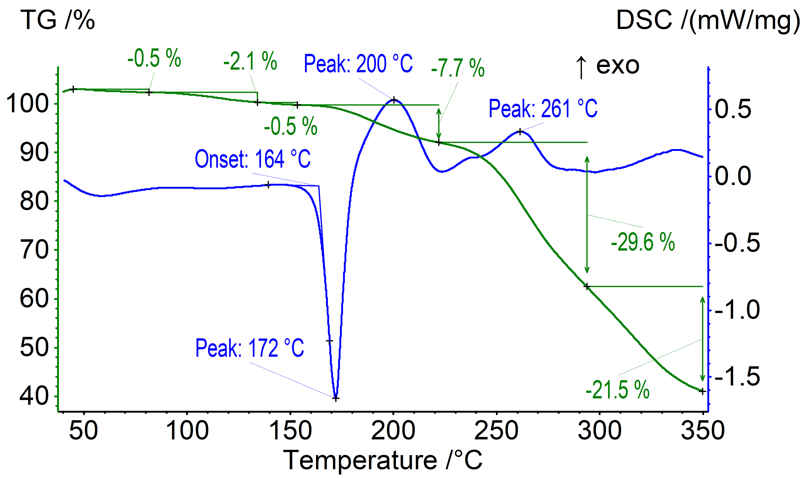

**Figure S1.** Results of TG/DSC analysis of mesityl(phenyl)phosphine oxide glycolate in the dynamic argon atmosphere 75 ml/min. Heating rate 10 °C/min.



**Figure S2.** Experimental diffractogram for mesityl(phenyl)phosphine oxide glycolate (blue curve), theoretical diffractogram calculated from data of single-crystal X-ray diffraction analysis of the compound mesityl(phenyl)phosphine oxide glycolate (red curve). For clarity, the curves are shifted relative to each other along the intensity axis.

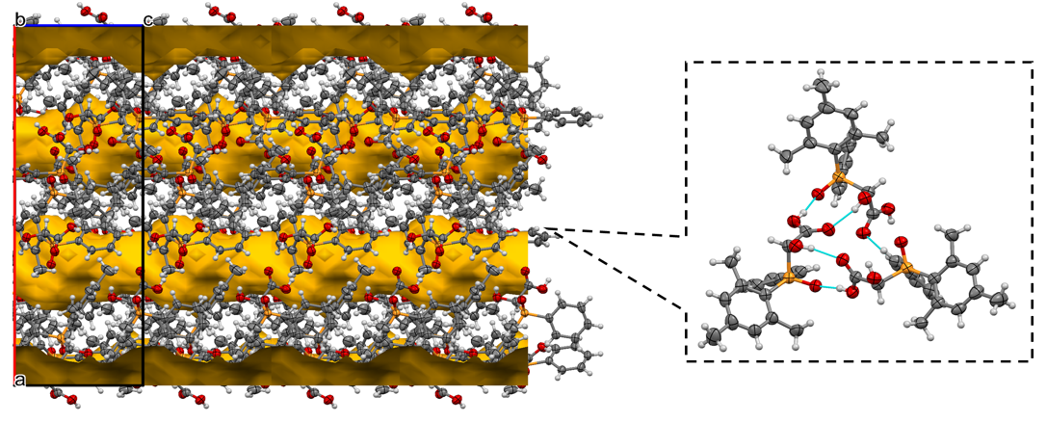

**Figure S3.** View of crystal packing of **1** along the *b* axis showing voids.

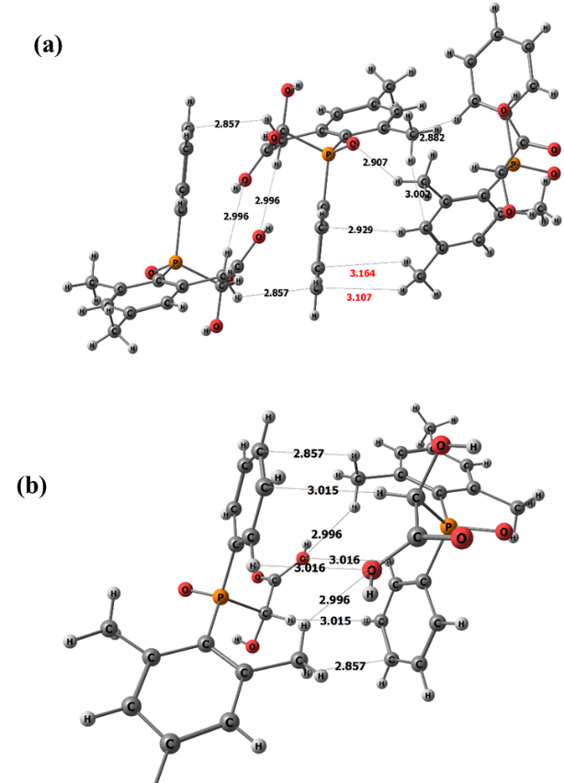

**Figure S4.** Fragments of crystal packing of **1** showing intermolecular interactions with two neighbors (a) responsible for 35.0 kJ/mol (left neighbor), and 34.3 kJ/mol (right neighbor) as well as 18.3 kJ/mol interaction (b).

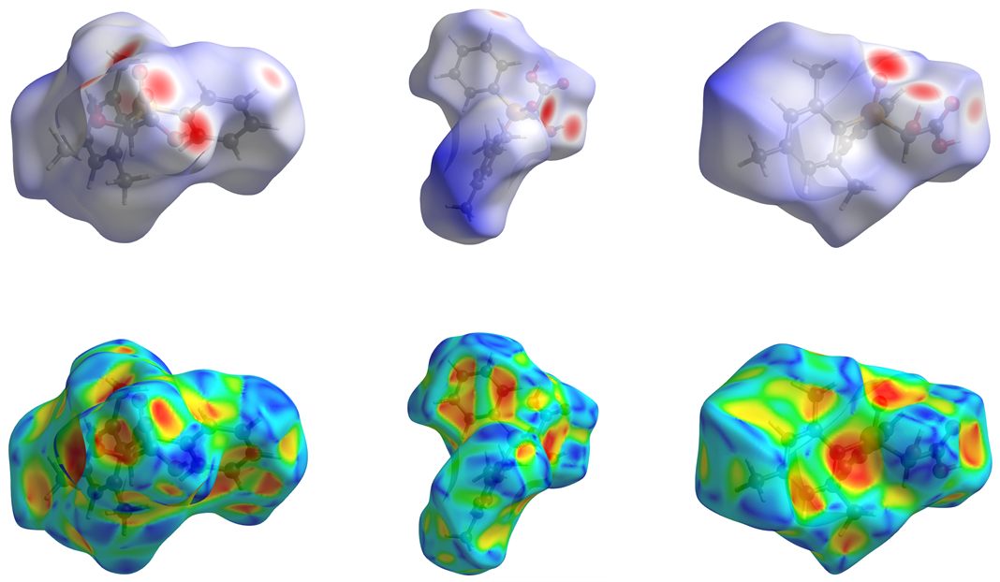

**Figure S5.** Hirshfield surface mapped dnorm along *a*, *b* and *с* axis (top) and Hirshfield surface mapped shape index along *a*, *b* and *с* axis (bottom).