**ELECTRONIC SUPPORTING INFORMATION (ESI)**

**Isomeric Protected Dipeptides Generated Stable Bio-compatible Gold Nanoparticles**

Sudeshna Kara,b* and Yian Taib*

aAssistant Professor, Department of Basic Science and Humanities (Chemistry), St. Thomas College of Engineering and Technology, 4, Diamond Harbour Rd, Alipore Body Guard Lines, Khidirpur, Kolkata, West Bengal 700023, Kolkata, India

bNational Taiwan University of Science and Technology, 43 Keelung Road, Taipei-106, Taiwan

*Corresponding author, E-mail: 06.sudeshna@gmail.com; [ytai@mail.ntust.edu.tw](mailto:ytai@mail.ntust.edu.tw)

Figure 1 
                  (a) UV-Visible spectra of the synthesized gold colloids, (b) its stability over times, and (c) manifestation of different colors of Au-NPs samples prepared from different ratios of the C. hindsii extract.
                Figure 1 
                  (a) UV-Visible spectra of the synthesized gold colloids, (b) its stability over times, and (c) manifestation of different colors of Au-NPs samples prepared from different ratios of the C. hindsii extract.
               

**Peptide I bound AuNPs Peptide II bound AuNPs**

**Figure S1:** The color of the newly synthesized AuNPs solutions.

**Table S1:** Experimental parameters of Zeta potential study.

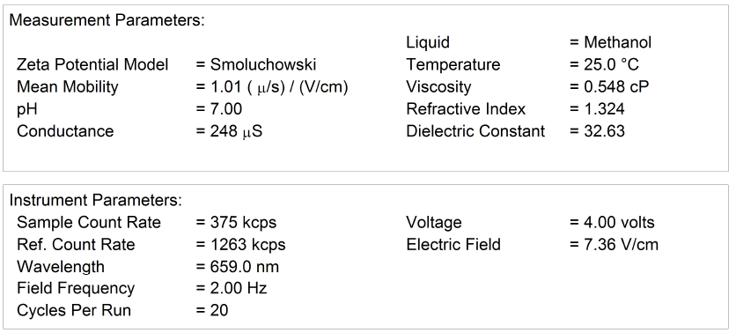

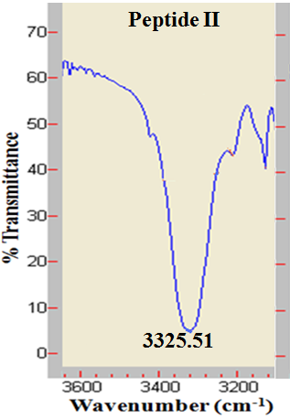 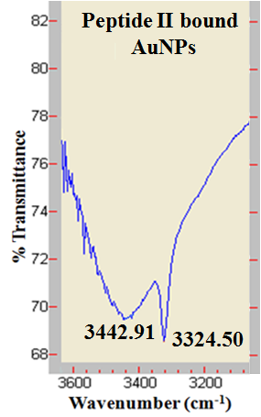

**Figure S2** FT**-**IR spectra of peptide **II** and peptide **II** bound gold nano-particles (AuNPs) in solid state (3200-3600 cm-1 range).

 

**Figure S3** FT**-**IR spectra of peptide **II** and peptide **II** bound gold nano-particles (AuNPs) in solid state (1640-1760 cm-1 range).



**Figure S4** 1H NMR spectrum of peptide **II** in DMSO-D6 (500 MHz) (7-10 ppm region).



**Figure S5** 1H NMR spectrum of peptide **I** bound AuNPs in DMSO-D6 (500 MHz) (7-10 ppm region).



**Figure S6** 1H NMR spectrum of peptide **II** in DMSO-D6 (500 MHz) (1-4 ppm region).



**Figure S7** 1H NMR spectrum of peptide **II** bound AuNPs in DMSO-D6 (500 MHz) (1-4 ppm region).

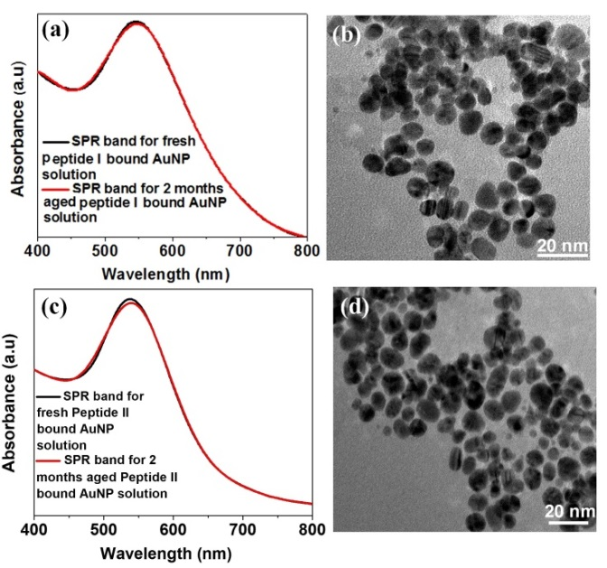

**Figure S8** (a) surface plasmon resonance band for freshly prepared peptide **I** bound AuNP solution and 2 months aged peptide **I**/AuNP solution are shown in the UV spectrum; (b) TEM image of 2 months aged peptide **I**/AuNP; (c) surface plasmon resonance band for freshly prepared peptide **II** bound AuNP solution and 2 months aged peptide **II**/AuNP solution are shown in the UV spectrum; (d) TEM image of 2 months aged peptide **II**/AuNP

**Table S2.**  Statistical results of MTT test

|  |  |  |  |  |  |
| --- | --- | --- | --- | --- | --- |
| **Sample** | **Control** | **Peptide I** | **Peptide II** | **Peptide I**  **AuNP** | **Peptide II**  **AuNP** |
| **Day 1** | 0.067 ±  0.002 | 0.082 ±  0.005 | 0.078 ±  0.006 | 0.075 ±  0.008 | 0.065 ±  0.007 |
| **Day 3** | 0.068 ±  0.003 | 0.065 ±  0.003 | 0.066 ±  0.007 | 0.075 ±  0.014 | 0.065 ±  0.002 |
| **Day 5** | 0.068 ±  0.010 | 0.066 ±  0.008 | 0.077 ±  0.005 | 0.08 ±  0.005 | 0.067 ±  0.013 |