Supplementary material to article
Green approach to production of porous char adsorbents via oxidative carbonization in fluidized catalyst bed

Petr M. Yeletsky*, Nikolay A. Yazykov, Yury V. Dubinin, Maksim M. Borodaevskiy, Svetlana A. Selishcheva and Vadim A. Yakovlev

Federal Research Center Boreskov Institute of catalysis SB RAS, Acad. Lavrentiev av., 5, Novosibirsk, 630090, Russian Federation
*Corresponding author: yeletsky@catalysis.ru

Table S1 – Texture characteristics, ash content and yield of chars from the feedstock carbonized in FCB reactor at 465 – 600 °C
Sample | A_{BET}, m²·g⁻¹ | A_{EXT}, m²·g⁻¹ | V_{Ʃ}, cm³·g⁻¹ |  | V_{µ}, cm³·g⁻¹ |  | <d_{pore}>, nm
Bran
B465 | 43 | 15 | 0.04 |  | 0.01 |  | 3.7
B550 | 91 | 40 | 0.05 |  | 0.02 |  | 2.2
B600 | 68 | 36 | 0.04 |  | 0.01 |  | 2.3
Rice husk
RH465 | 87 | 82 | 0.13 |  | 0 |  | 6.0
RH550 | 117 | 102 | 0.17 |  | 0.01 |  | 5.8
RH600 | 99 | 78 | 0.18 |  | 0.01 |  | 7.4
Peat
P465 | 11 | 11 |  | 0.05 |  | 0 |  | 19.5
P550 | 9 | 10 |  | 0.06 |  | 0 |  | 28.5
P600 | 7 | 7 |  | 0.05 |  | 0 |  | 32.7
Coal
C465 | 133 | 61 |  | 0.07 |  | 0.03 |  | 2.1
C550 | 126 | 68 |  | 0.07 |  | 0.02 |  | 2.1
C600 | 172 | 92 |  | 0.09 |  | 0.03 |  | 2.1

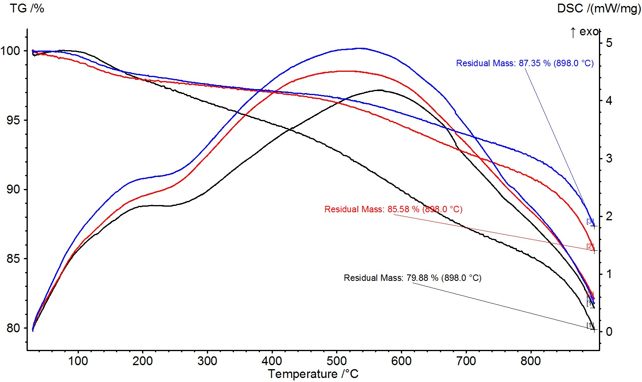
Figure S1 – TG and DSC profiles of WB-derived char samples obtained at 465 – 600 °C

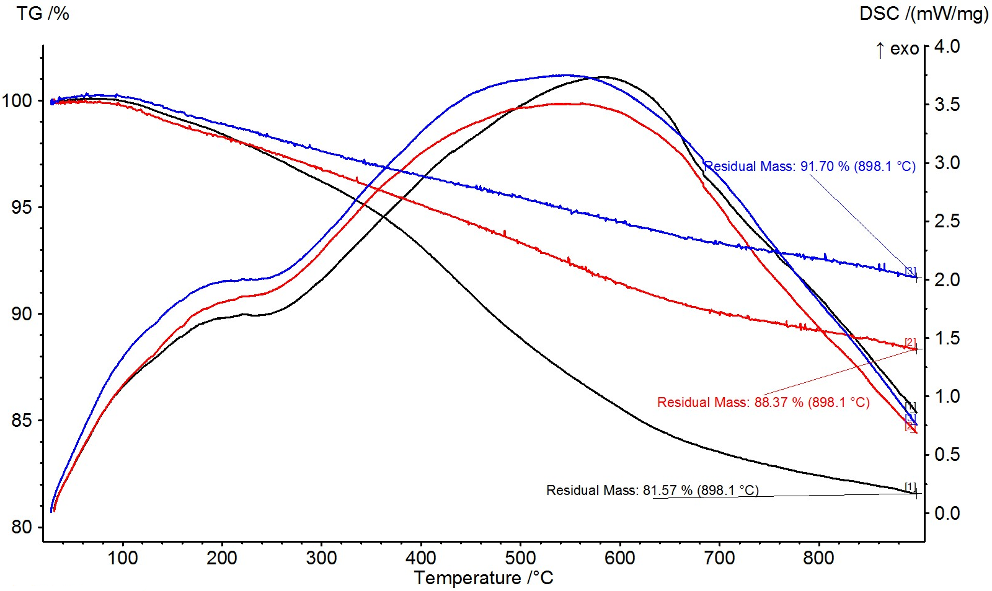
Figure S2 – TG and DSC profiles of RH-derived char samples obtained at 465 – 600 °C

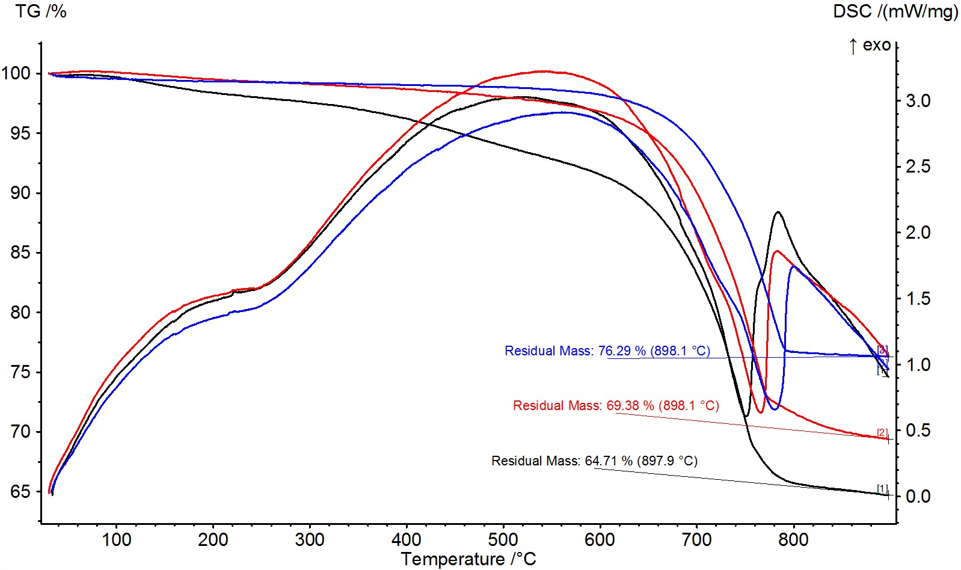
Figure S3 – TG and DSC profiles of peat-derived char samples obtained at 465 – 600 °C

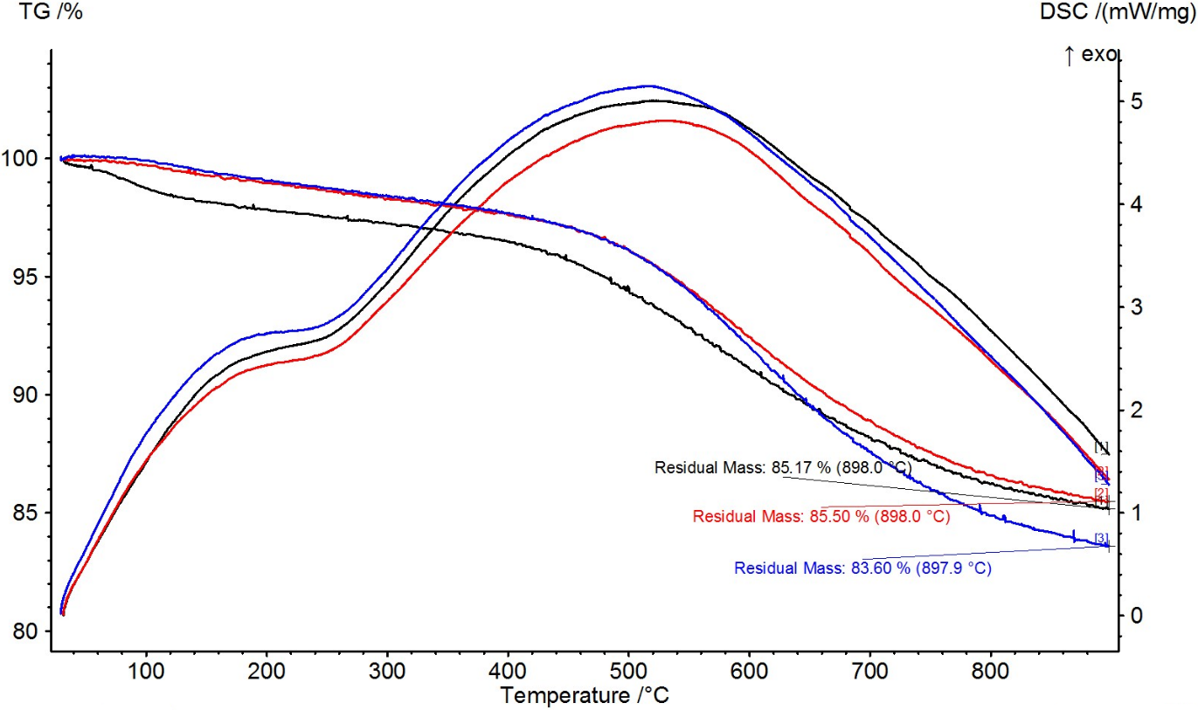
Figure S4 – TG and DSC profiles of coal-derived char samples obtained at 465 – 600 °C

