**Supplementary material:**

**Table S1.** Results of EDX: nominal composition of samples in the form of mole fraction (*x*)in La1-*x*Gd*x*PO4·(*n*H2O) synthesized under soft chemistry methods.

|  |  |  |  |  |
| --- | --- | --- | --- | --- |
| Nominal composition, *x* | in precipitated samples | Hydrothermal synthesis at 230°C | | |
| isothermal holding times of 2 hours | isothermal holding times of 3 days | isothermal holding times of 5 days |
| 0.00 | 0.00 | 0.00 | 0.00 | 0.00 |
| 0.20 | 0.20±0.06 | 0.20±0.05 | 0.19±0.02 | 0.21±0.03 |
| 0.50 | 0.48±0.03 | 0.50±0.04 | 0.49±0.05 | 0.50±0.06 |
| 0.75 | 0.76±0.04 | 0.75±0.05 | 0.75±0.02 | 0.79±0.03 |
| 0.85 | 0.85±0.03 | 0.86±0.04 | 0.85±0.01 | 0.89±0.01 |
| 1.00 | 1.00 | 1.00 | 1.00 | 1.00 |

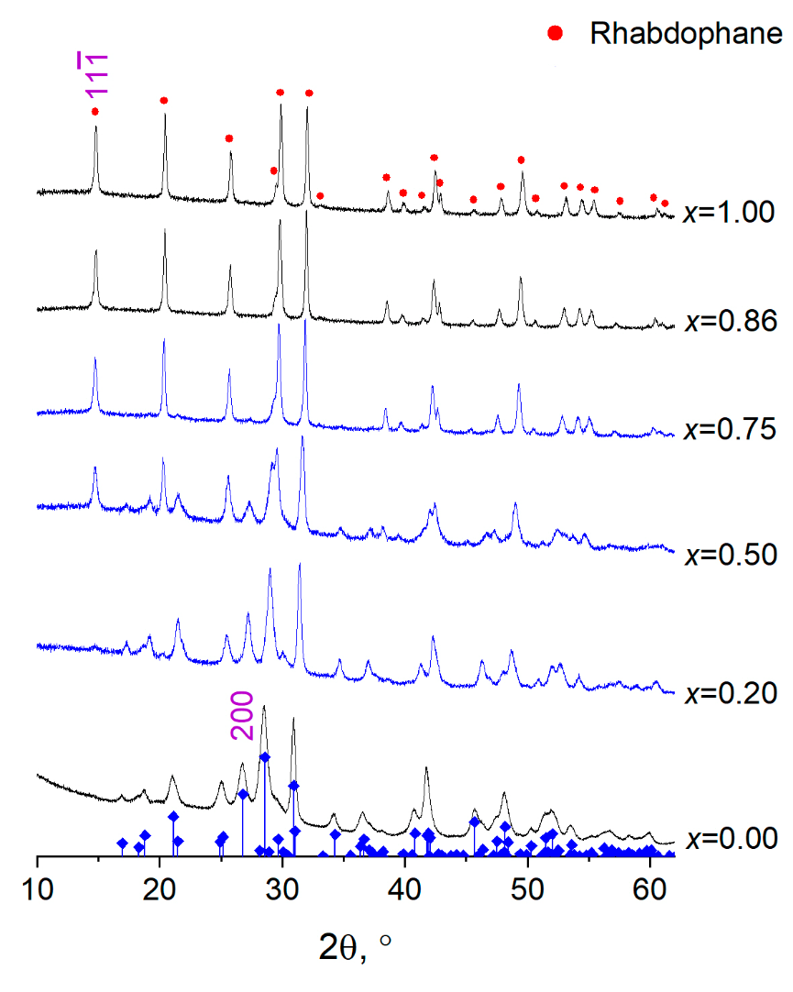

**Figure S1.** Diffraction patterns of samples in the La1-*x*Gd*x*PO4·(*n*H2O) system with structures of

monazite and rhabdophane, obtained using hydrothermal treatment at 230°C for 2 hours of isothermal holding. The vertical lines correspond to the phase with the monazite structure [Ni Y., Hughes J.M., Mariano A.N. Crystal chemistry of the monazite and xenotime structures. *American Minerologist*, 1995, **80**, P. 21-26.].

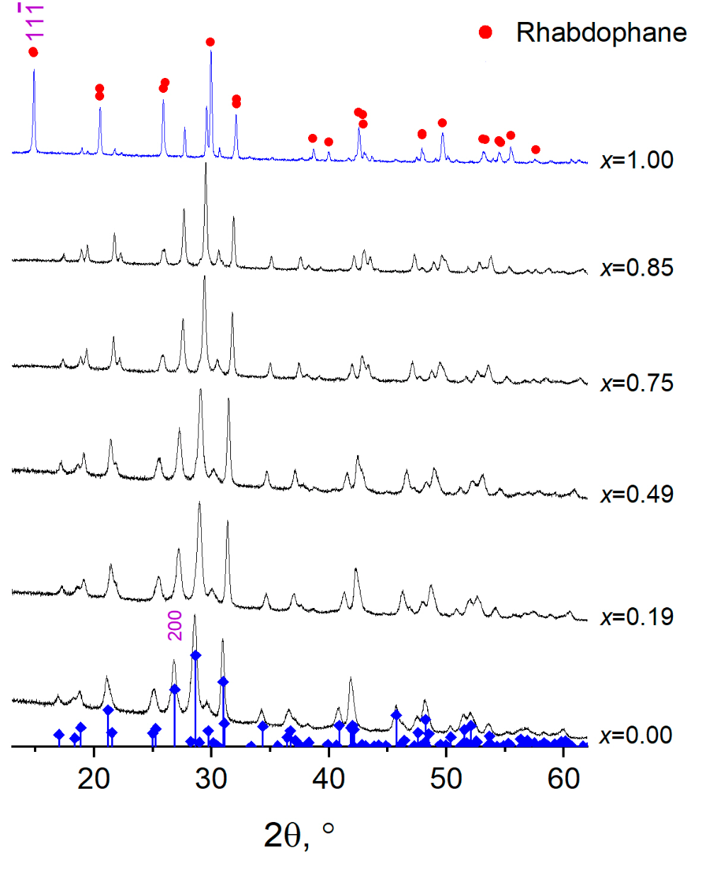

**Figure S2.** Diffraction patterns of samples in the La1-*x*Gd*x*PO4·(*n*H2O) system with structures of

monazite and rhabdophane, obtained using hydrothermal treatment at 230°C for 3 days of isothermal holding. The vertical lines correspond to the phase with the monazite structure.

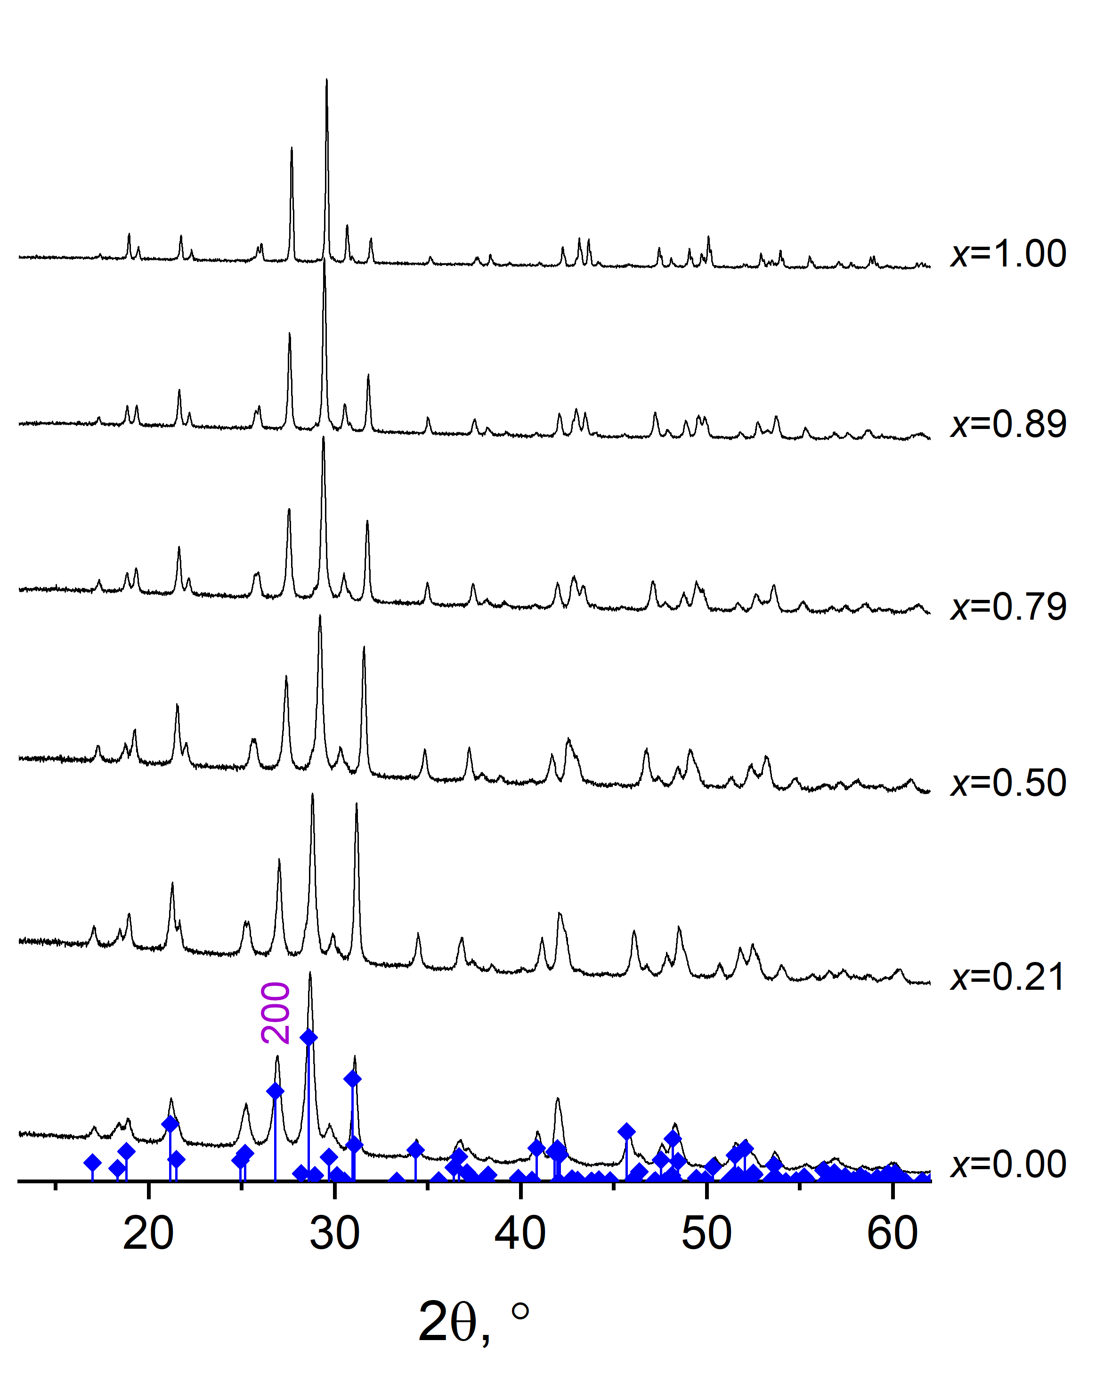

**Figure S3.** Diffraction patterns of samples in the La1-*x*Gd*x*PO4 system with structure of

monazite, obtained using hydrothermal treatment at 230°C for 5 days of isothermal holding. The vertical lines correspond to the phase with the monazite structure.

**Таблица S2.** Thermal analysis data for samples obtained by precipitation, where Δ*T*, °C is the temperature range of mass change; *n* is the number of water molecules in the structure of rhabdophane (La1-*x*Gd*x*PO4·*n*H2O), *T*onset,°C is the temperature of the onset of the exothermic effect associated with the structural transformation rhabdophane → monazite.

|  |  |  |  |  |  |
| --- | --- | --- | --- | --- | --- |
| Sample | Step | Δ*Т*, °С | *n* | | *T*onset*, °С* |
| *x*=0.00 | 1 | 130-201 | 0.25 | 0.97 | 601 |
| 2 | 201-295 | 0.46 |
| 3 | 295-800 | 0.26 |
| *x*=0.20 | 1 | 123-190 | 0.29 | 1.01 | 662 |
| 2 | 190-274 | 0.48 |
| 3 | 274-800 | 0.24 |
| *x*=0.48 | 1 | 130-183 | 0.25 | 0.95 | 701 |
| 2 | 183-270 | 0.49 |
| 3 | 270-800 | 0.21 |
| *x*=0.76 | 1 | 123-178 | 0.21 | 0.86 | 728 |
| 2 | 178-257 | 0.48 |
| 3 | 257-800 | 0.17 |
| *x*=0.85 | 1 | 122-180 | 0.20 | 0.89 | 734 |
| 2 | 180-247 | 0.47 |
| 3 | 24-800 | 0.22 |
| *x*=1.00 | 1 | 114-158 | 0.16 | 0.82 | 733 |
| 2 | 158-225 | 0.44 |
| 3 | 225-800 | 0.26 |