Supplementary Information

**Granular Ni-Mo-W bulk hydrotreating catalyst: the effects from precursor calcination**

**K. A. Nadeina, Yu. V. Vatutina, P. P. Mukhacheva, S. V. Budukva, I. G. Danilova, V. P. Pakharukova, E. Yu. Gerasimov, M. A. Panafidin, O. V. Klimov**

Boreskov Institute of Catalysis SB RAS, Lavrentiev Ave. 5, Novosibirsk, Russia, 630090

**\* Corresponding author.**

E-mail address: : [lakmallow@catalysis.ru](mailto:lakmallow@catalysis.ru) (K.A. Nadeina)

Figure SI1 – XRD data of granulated catalyst with different precursor calcination temperature and catalysts calcination temperature

Figure SI2 – Nitrogen adsorption-desorption isotherms and pore size distribution curves for granulated calcined catalysts

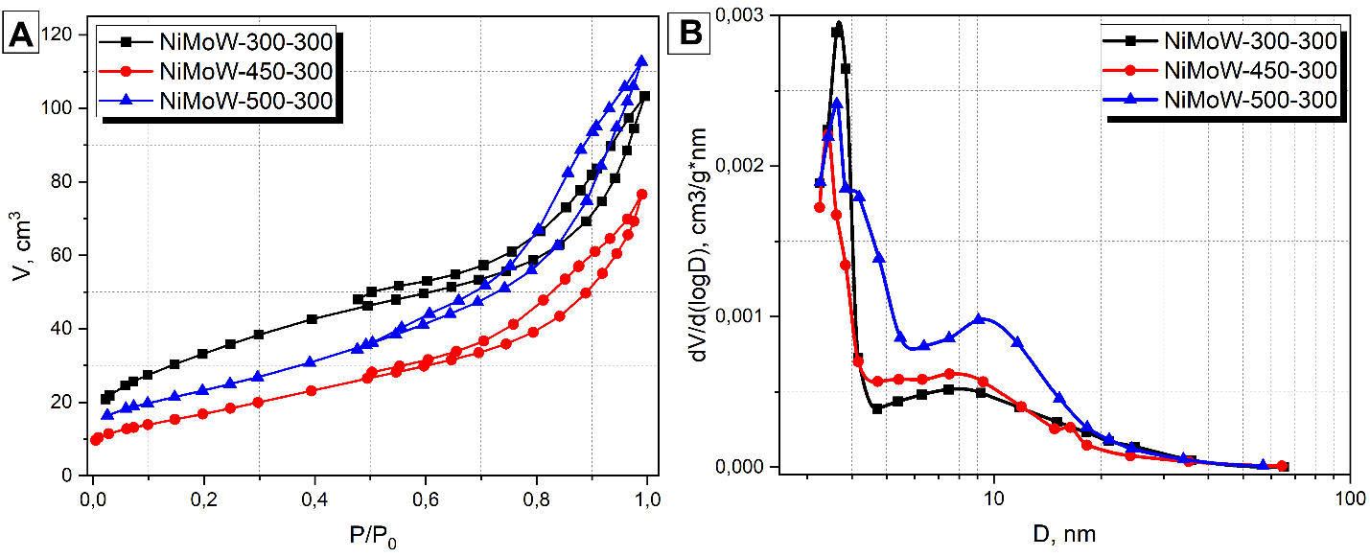

Figure SI3 — Pore size distribution curves for sulfided catalysts after reaction

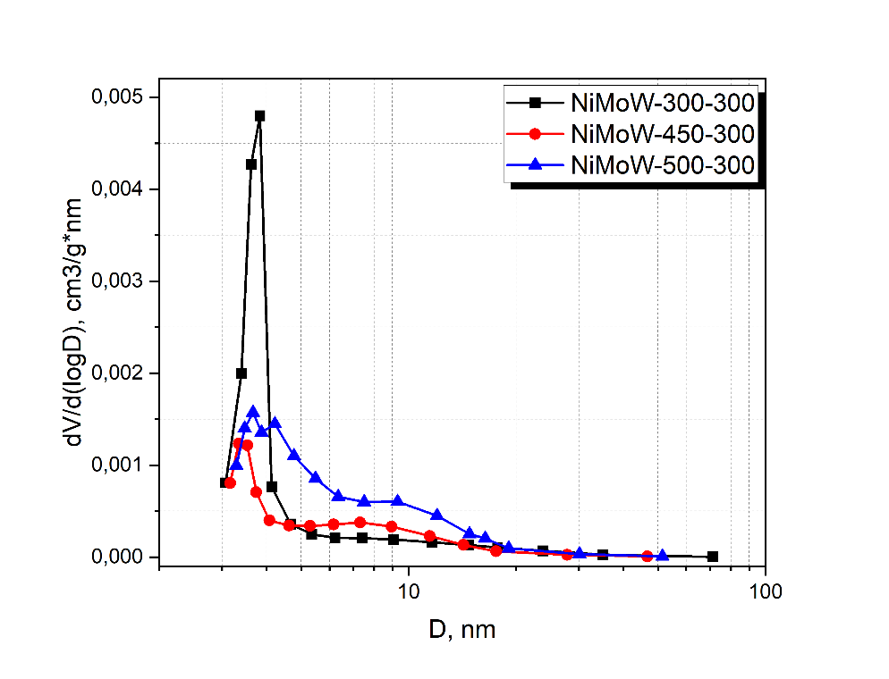

Figure SI4 – HAADF data on the NiMoW-450-300 catalyst before testing

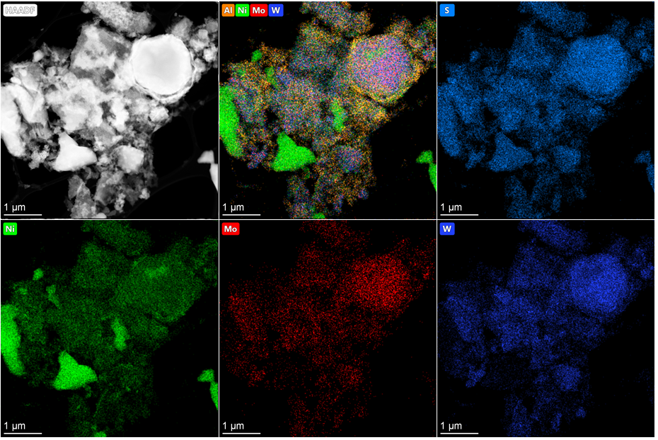

Figure SI5 – HAADF data on the NiMoW-500-300 catalyst before testing

