UDC 544.2;544.6;66.097;542.97

La and Co-based materials for ammonia decomposition: activity, stability and structural changes

Vadim A. Borisov¹*, Zaliya A. Fedorova², Evgeniy Y. Gerasimov², Dmitry A. Shlyapin², Anna Y. Stroeva³, Victor L. Temerev¹, Alexey B. Arbuzov¹, Zakhar N. Ichetovkin^{3,4}, Sergey V. Tsybulya², Pavel V. Snytnikov² and Anton V. Kuzmin³

¹Center of New Chemical Technologies BIC, Boreskov Institute of Catalysis,
Neftezavodskaya, 54, Omsk, 644040, Russia

²Boreskov Institute of Catalysis,

pr. Akademika Lavrentieva, 5, Novosibirsk, 630090, Russia

³Department of Technology of Inorganic Materials and Electrochemical Production,

Vyatka State University,

Moskovskaya, 36, Kirov, 610000, Russia

⁴Institute of Solid State Chemistry and Mechanochemistry of the Siberian Branch of the RAS, Kutateladze, 18, Novosibirsk, 630128, Russia

Corresponding author: borisovtiger86@mail.ru

Thermal expansion coefficients of La-containing initial materials and composites
To produce PCFC, it is necessary that the thermal expansion coefficient (TEC) of the materials included in its composition differ from each other by no more than 30%. Therefore, first of all, we carried out measurements of the original materials and all composites based on them. The temperature dependences of linear expansion for composite samples were measured in a cooling regime 900-25 °C to eliminate the influence of desorption processes. No effects related to the first or second order phase transitions were observed. The thermal expansion coefficients (TEC) were determined at the temperature dependences of 100-900 ºС. Since lanthanum cobaltite has the high TEС value, the TEС of composite the more than the more LC content (Table S1). The electrolytes based on lanthanum scandate has the TEС values of 8.5 × 10⁻⁶ to 9.7 × 10⁻⁶ deg⁻¹.^{[55]} The difference between the TEС with lanthanum scandate-based electrolytes and the investigated composites is less than 30%, which is an acceptable discrepancy in magnitude, especially since electrode materials are more often formed in a highly porous state. For comparison, the table shows the TEС values of the components of the studied composite materials La_{0.9}Sr_{0.1}Sc_{0.1}O_{3-δ} (LS) and La_{0.9}Sr_{0.1}CoO_{3-δ} (LС). The other known electron conducting materials reported in the literature ^{[56-58]} have higher TEC values. Thus, LS/LC-based composites are compatible in thermal expansion with lanthanum scandate-based electrolytes.
Table S1. TEC values of composite oxides 100-900°C compared with literature data
Composition | TEC _{373-1173 K} × 10⁻⁶ (K⁻¹) | Reference
40LS–60LC | 14.56 ± 0.5 | This work
50LS–50LC | 13.86 ± 0.5 | This work
60LS–40LC | 12.69 ± 0.5 | This work
LS | 10.49 ± 0.5 | This work
La_{0.9}Sr_{0.1}CoO_{3-δ} | 21.54 ± 0.5 | ^{[59]}
La_{0.9}Sr_{0.1}ScO_{3-δ} | 9.02 ± 0.1 | ^{[55]}
X-ray fluorescence spectroscopy
The elemental composition of individual and composite materials was determined by X-ray fluorescence spectroscopy. Table S2 presents the results of this investigation. As we can see, the composition of LC, LS and the mixed materials is in close correspondence with the formulas La_{0.9}Sr_{0.1}Sc_{0.9}Co_{0.1}O_{3-δ} and La_{0.9}Sr_{0.1}CoO_{3-δ}. Small variations are caused by the presence of chromium and zirconium impurities associated with the method of obtaining these materials. It should also be noted that some quality of scandium is present in the LC phase.
Table S2. The elemental composition of LS-LC based materials.
 | LC | LS | 60LS-40LC | 50LS-50LC | 40LS-60LC
Element | Mass % | Mass % | Mass % | Mass % | Mass %
La | 54.42 | 55.93 | 55.07 | 54.88 | 56.01
Sr | 3.49 | 4.67 | 3.87 | 3.98 | 4.16
Co | 24.29 | 3.52 | 13.07 | 13.21 | 13.58
Sc | 0.57 | 15.57 | 8.37 | 8.15 | 8.49
Cr | 0.07 | 0.08 | 0.07 | 0.07 | 0.07
Zr |  | 0.1 | 0.17 | 0.13 | 0.14

X-ray phase analysis of La-containing initial materials and composites
The X-ray phase analysis of the composite materials showed the absence of additional phase peaks after sintering (Fig. 1).
Figure S1. XRD patterns of composites 40LS-60LC; 50LS-50LC and 60LS-40LC
XRD data show that individual LS and LC are single-phase materials with perovskite type structure with space groups Pnma of rhombic symmetry (LS) and R-3c of rhombohedral symmetry (LC). The X-ray diffraction diagram of the initial lanthanum cobaltite LC shows the LaCoO₃ phase [PDF 25-1060], and in the material tested in the ammonia decomposition reaction, the phase La(OH)₃ [PDF 36-1481] and metallic cobalt [PDF 15-0806] are presents. The initial LS-LC samples are the two-phase system consisting of LaCoO₃ and LaScO₃ [PDF 26-1148]. The XRD patterns of the LS-LC samples after testing in ammonia decomposition contain only one initial phase peaks - LaScO₃. In addition, the La(OH)₃ and metallic cobalt [PDF 15-0806] phases are also detected in the composite sample after testing. The composition of the initial materials and composites is also confirmed by X-ray fluorescence analysis (Table S1).
Temperature dependences of the electrical resistivity of La-containing initial materials and composites
Since the temperature dependence of the electrical resistance is an important characteristic of the materials included in the PCFC, this dependence has been studied for individual LS and LC, and composite materials. Figure S2 shows the temperature dependences of the electrical resistivity of composite materials. It is seen that they have a non-linear form, their curvature increases with a decrease in the LC concentration. It is shown that in the low temperature range, there is a tendency towards semiconductor type of conductivity. A further increase in temperature leads to a decrease in resistivity for all materials, which is typical of a metallic type of conductivity. The semiconductor-metal transition is associated either with the existence of collectivized electrons due to the overlap of two zones of the binding and loosening bonds σ_{x2-y2}, or with a decrease in the concentration of holes due to the loss of interstitial oxygen.^{[60]}
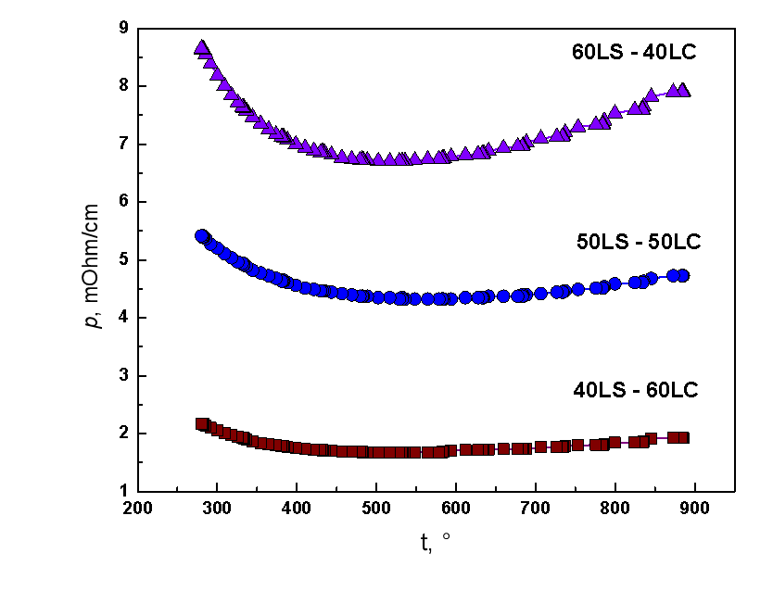
Figure S2. Temperature dependencies of the electrical resistivity of composite materials LS-LC.
In general, the type and the level of conductivity of the composites are closer to LC.^{[61]} The La_{0.9}Sr_{0.1}Sc_{1-x}Co_{x}O_{3-δ} compounds have a linear downward dependence of electrical conductivity, the values of which are three orders of magnitude lower than those of the studied composites.^{[62]}
Temperature programmed reduction
The reducibility of synthesized oxide materials were studied by TPR. The TPR spectrum of the initial LC material exhibits two intense peaks. The TPR spectrum of the composite materials also exhibits two intense peaks (Fig.S3), which are related to the two-step reduction of Co₃O₄ to metallic cobalt via CoO.

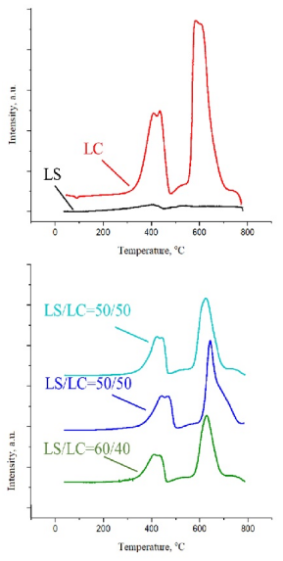
Fig.S3. TPR spectrum of LS and LC and composite LS-LC materials.
According to TPR data, in a reducing environment at a temperature of 400 °C, the cobalt present in the LC phase is reduced to CoO, and at temperatures above 600 °C transformed to metallic cobalt. Therefore, it can be assumed that the activity of composites in the synthesis of ammonia is associated with the migration of cobalt from LC, its reduction in the reaction medium and localization on the surface in the form of metal particles.
HR TEM mapping data
Table S3 Initial 50LS-50LC composite
Element | Atomic fraction, %
O | 52.78
Sc | 14.00
Co | 9.74
Sr | 2.16
La | 21.32

Table S4: 50LS-50LC composite after reaction (area 1)
Element | Atomic fraction, %
O | 57.15
Sc | 19.91
Co | 2.91
Sr | 1.21
La | 18.83

Table S5: 50LS-50LC composite after reaction (area 2)
Element | Atomic fraction, %
O | 60.14
Sc | 10.64
Co | 9.70
Sr | 3.12
La | 16.40

