Supplementary
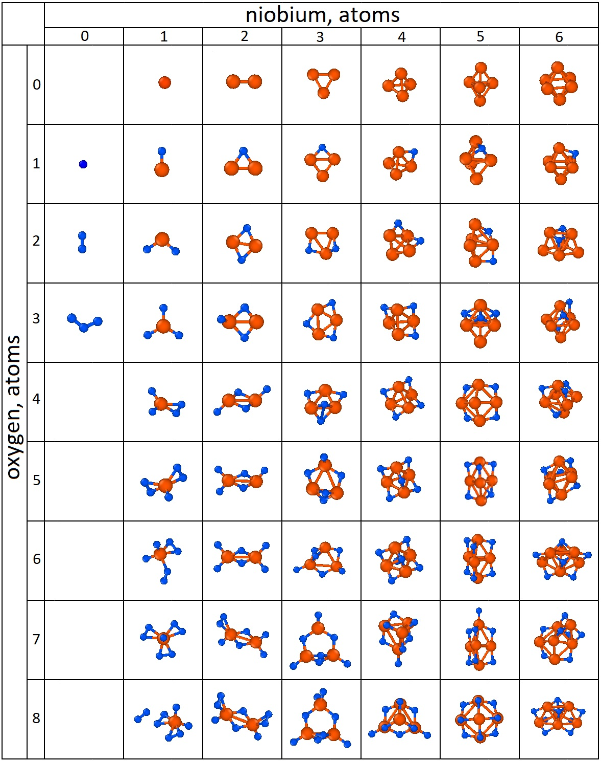Fig. S1. Structure of the most stable Nb_{n}O_{m} clusters as a function of n and m indices, identified using the USPEX evolutionary algorithm coupled with ORB v3 calculations. Nb and O atoms are represented by large orange and small blue spheres, respectively.

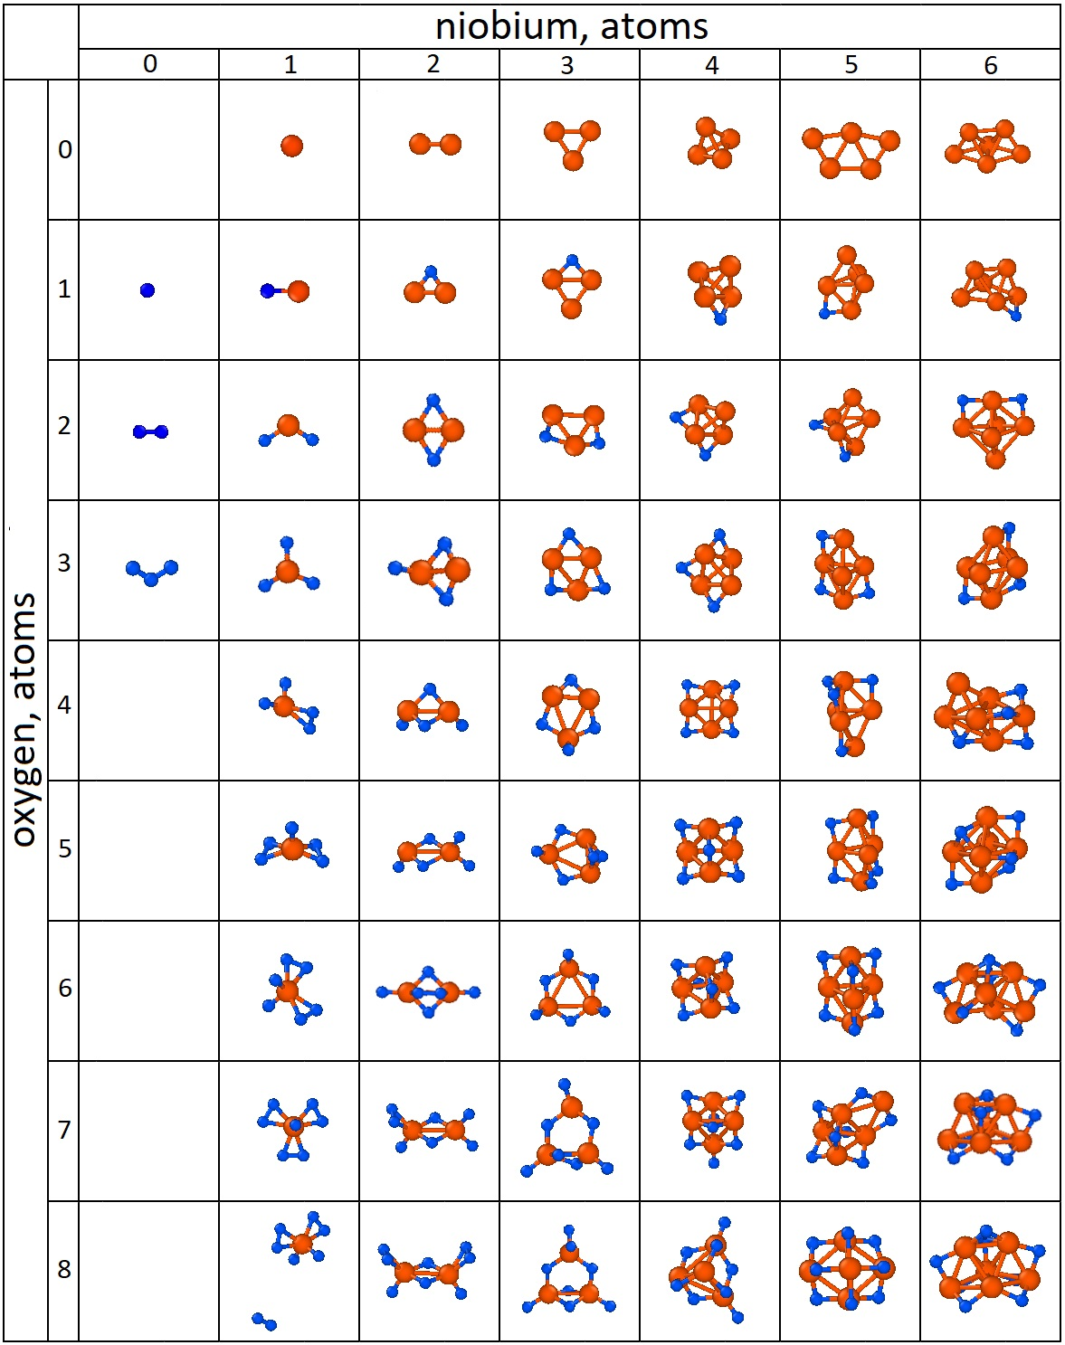Fig. S2. Structure of the most stable Nb_{n}O_{m} clusters as a function of n and m indices, identified using the USPEX evolutionary algorithm coupled with UMA(m) calculations. Nb and O atoms are represented by large orange and small blue spheres, respectively.

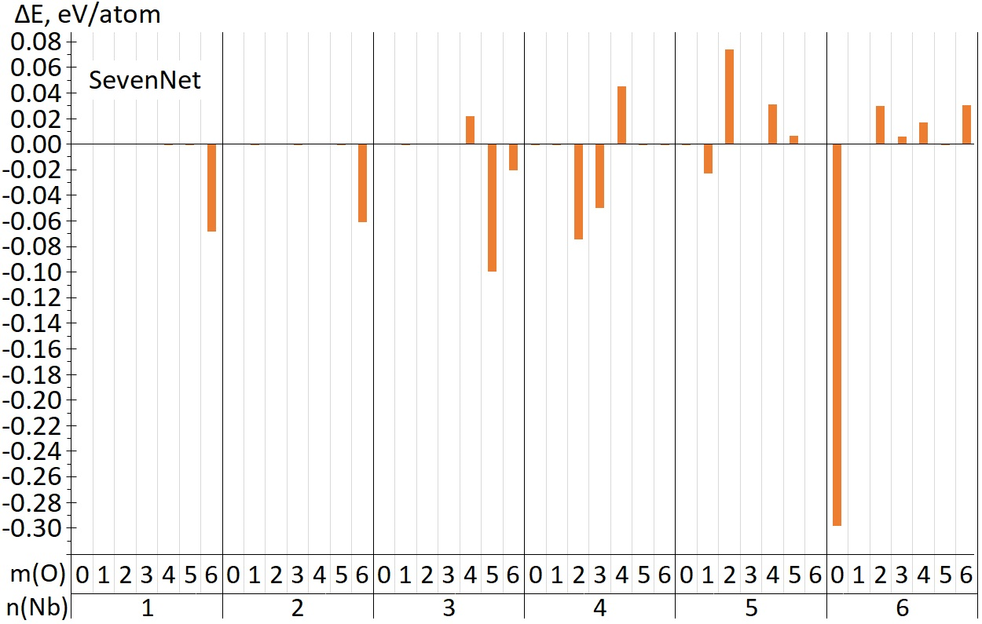
Fig. S3. Energy difference between the most stable clusters found by USPEX+SevenNet and USPEX+DFT. The global minimum structures found via the USPEX+DFT approach were re-optimized and their energies were recalculated using the SevenNet potential.

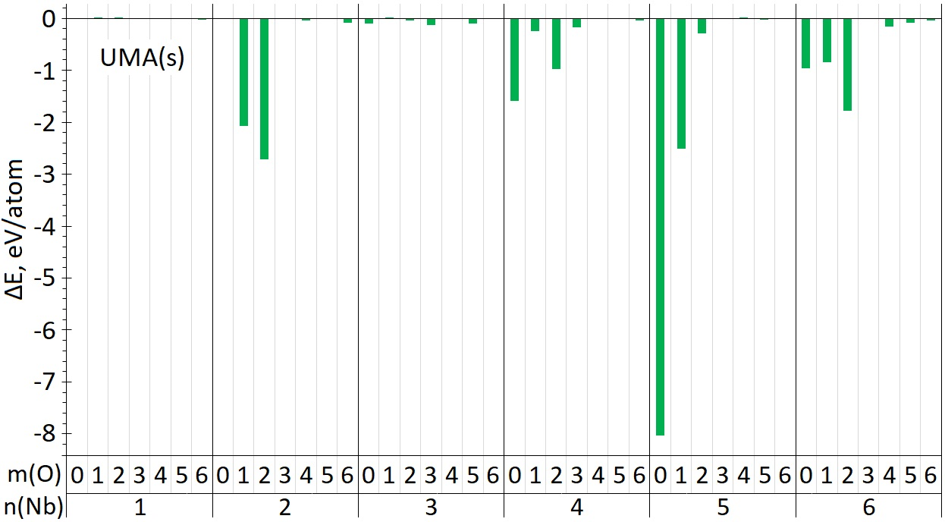
Fig. S4. Energy difference between the most stable clusters found by USPEX+UMA(s) and USPEX+DFT. The global minimum structures found via the USPEX+DFT approach were re-optimized and their energies were recalculated using the UMA(s) potential.

