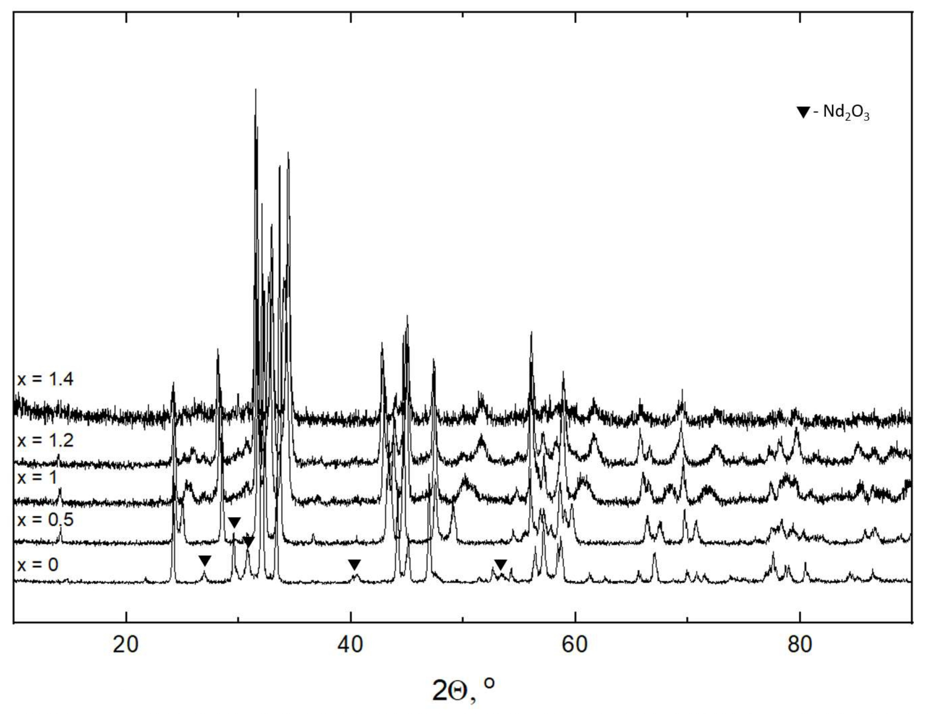

Fig. S1. XRD patterns of the partial reduction products of Nd_{2-x}Sr_{x}NiO_{4-δ} at 500 °C.

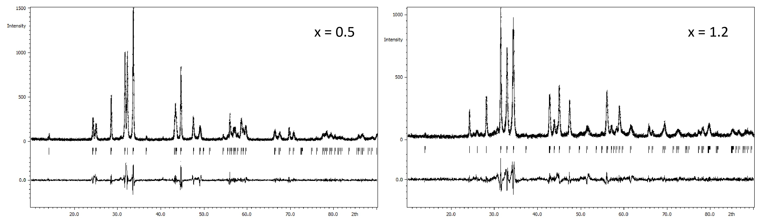

Fig. S2. Le Bail refinement plots of the several partial reduction products of Nd_{2 x}Sr_{x}NiO_{4-δ} ₋ at 500 °C.
Table S1. A selectivity, productivity, and conversion products of the catalytic hydrogenation of CO2 by the products of partial reduction of Nd_{2-x}Sr_{x}NiO_{4-δ} at various temperatures.
Sample | Т, ℃ | Selectivity, % |  | Hydrocarbons, % |  |  |  |  |  | Productivity  ( mole CO₂ *m_{cat(kg)}⁻¹ *t(h)⁻¹)
Sample | Т, ℃ | CO | HC | C₁ | C₂ | C₃ | C₄ | C₅ | C₆₊ | Productivity  ( mole CO₂ *m_{cat(kg)}⁻¹ *t(h)⁻¹)
x=0 | 250 | 68.88 | 31.12 | 99.46 | 0.54 | 0 | 0 | 0 | 0 | 0.10
x=0 | 300 | 69.45 | 30.55 | 81.36 | 0.69 | 0.02 | 0.03 | 0 | 0 | 2.19
x=0 | 350 | 77.93 | 22.07 | 98.37 | 1.40 | 0.06 | 0.04 | 0 | 0 | 8.73
x=0 | 400 | 89.04 | 10.96 | 96.08 | 3.25 | 0.47 | 0.08 | 0.01 | 0 | 18.16
x=0.5 | 250 | 98.16 | 1.84 | 99.35 | 0.47 | 0 | 0.06 | 0 | 0 | 0.43
x=0.5 | 300 | 90.11 | 9.89 | 99.23 | 0.62 | 0.06 | 0.04 | 0 | 0 | 0.93
x=0.5 | 350 | 94.02 | 5.98 | 98.40 | 1.41 | 0.13 | 0.03 | 0 | 0 | 4.61
x=0.5 | 400 | 96.37 | 3.63 | 98.32 | 1.52 | 0.13 | 0.01 | 0 | 0 | 9.49
x=1 | 250 | 93.88 | 6.12 | 97.89 | 0.44 | 0.00 | 0.79 | 0.46 | 0 | 0.07
x=1 | 300 | 95.24 | 4.76 | 99.45 | 0.47 | 0.02 | 0 | 0 | 0 | 1.24
x=1 | 350 | 96.01 | 3.99 | 98.90 | 0.98 | 0.07 | 0.01 | 0 | 0 | 4.53
x=1 | 400 | 94.26 | 5.74 | 98.87 | 1.02 | 0.09 | 0.01 | 0 | 0 | 10.76
x=1.2 | 250 | 91.39 | 8.61 | 99.44 | 0.50 | 0 | 0.06 | 0 | 0 | 0.10
x=1.2 | 300 | 92.46 | 7.54 | 99.53 | 0.41 | 0.01 | 0.01 | 0 | 0 | 1.54
x=1.2 | 350 | 90.21 | 9.79 | 99.45 | 0.53 | 0 | 0 | 0 | 0 | 6.40
x=1.2 | 400 | 91.23 | 8.77 | 99.50 | 0.48 | 0.01 | 0 | 0 | 0 | 15.10
x=1.4 | 250 | 61.31 | 38.69 | 99.73 | 0.27 | 0 | 0 | 0 | 0 | 0.04
x=1.4 | 300 | 80.75 | 19.25 | 99.68 | 0.32 | 0 | 0 | 0 | 0 | 0.53
x=1.4 | 350 | 84.04 | 15.96 | 99.62 | 0.36 | 0.01 | 0 | 0 | 0 | 2.79
x=1.4 | 400 | 84.45 | 15.55 | 99.58 | 0.40 | 0.02 | 0 | 0 | 0 | 9.66

