Supplementary material:
Table S1. Results of EDX: nominal composition of samples in the form of mole fraction (x) in La_{1-x}Gd_{x}PO₄·(nH₂O) synthesized under soft chemistry methods.
Nominal composition, x | in precipitated samples | Hydrothermal synthesis at 230°C
Nominal composition, x | in precipitated samples | isothermal holding times of 2 hours | isothermal holding times of 3 days | isothermal holding times of 5 days
0.00 | 0.00 | 0.00 | 0.00 | 0.00
0.20 | 0.20±0.06 | 0.20±0.05 | 0.19±0.02 | 0.21±0.03
0.50 | 0.48±0.03 | 0.50±0.04 | 0.49±0.05 | 0.50±0.06
0.75 | 0.76±0.04 | 0.75±0.05 | 0.75±0.02 | 0.79±0.03
0.85 | 0.85±0.03 | 0.86±0.04 | 0.85±0.01 | 0.89±0.01
1.00 | 1.00 | 1.00 | 1.00 | 1.00
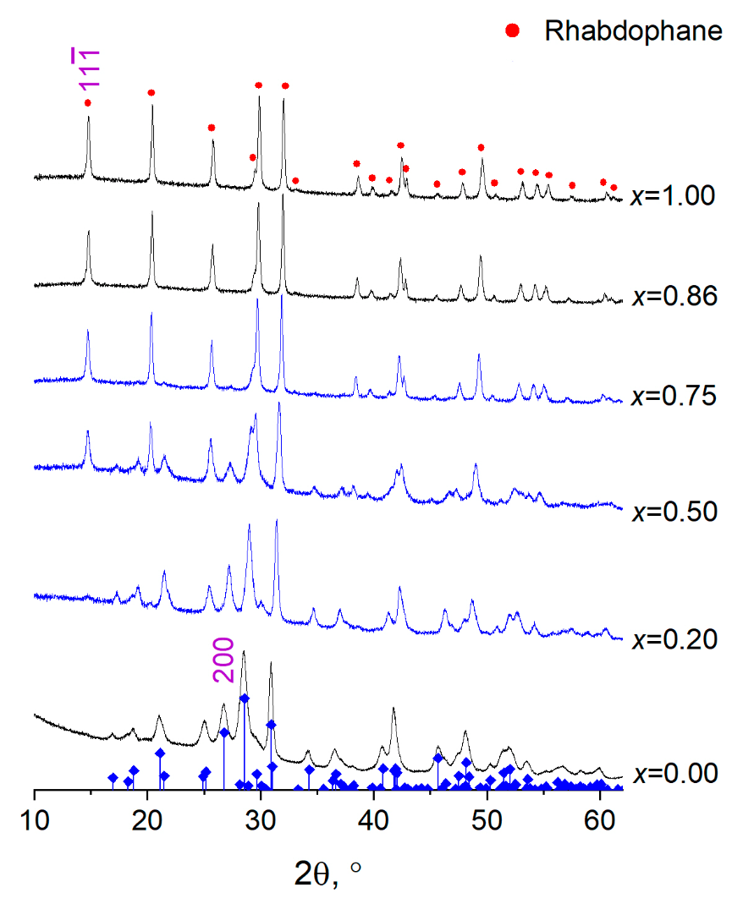
Figure S1. Diffraction patterns of samples in the La_{1-x}Gd_{x}PO₄·(nH₂O) system with structures of
monazite and rhabdophane, obtained using hydrothermal treatment at 230°C for 2 hours of isothermal holding. The vertical lines correspond to the phase with the monazite structure [Ni Y., Hughes J.M., Mariano A.N. Crystal chemistry of the monazite and xenotime structures. American Minerologist, 1995, 80, P. 21-26.].
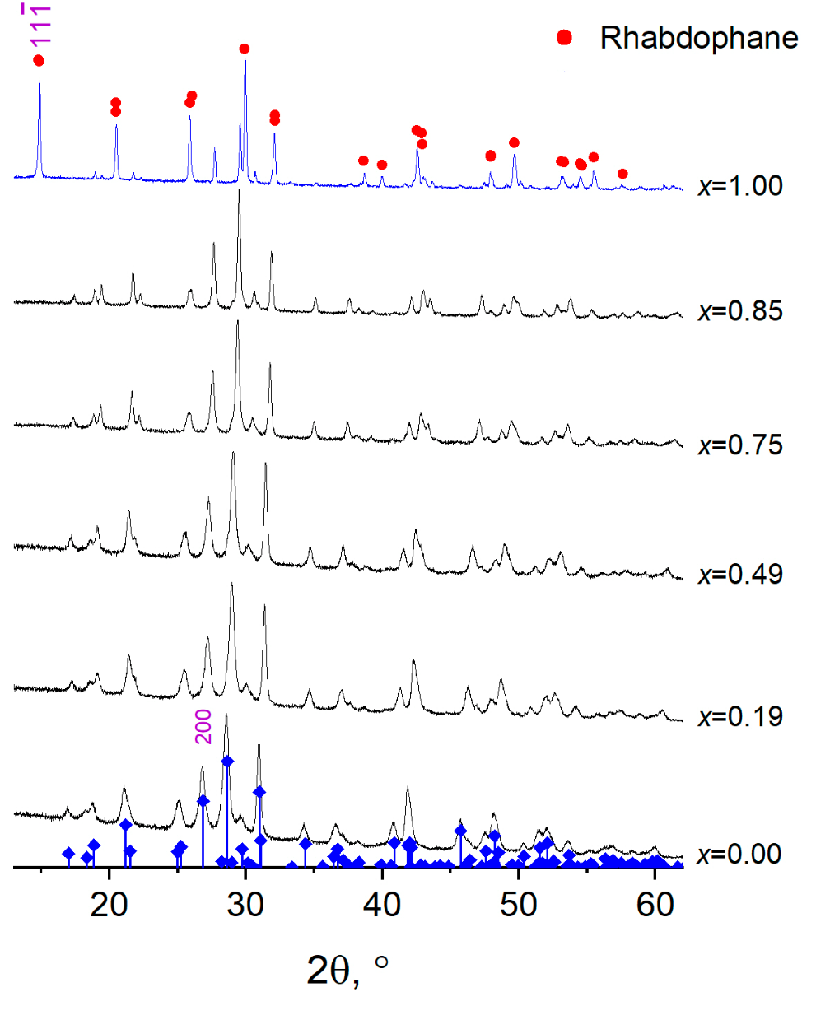
Figure S2. Diffraction patterns of samples in the La_{1-x}Gd_{x}PO₄·(nH₂O) system with structures of
monazite and rhabdophane, obtained using hydrothermal treatment at 230°C for 3 days of isothermal holding. The vertical lines correspond to the phase with the monazite structure.

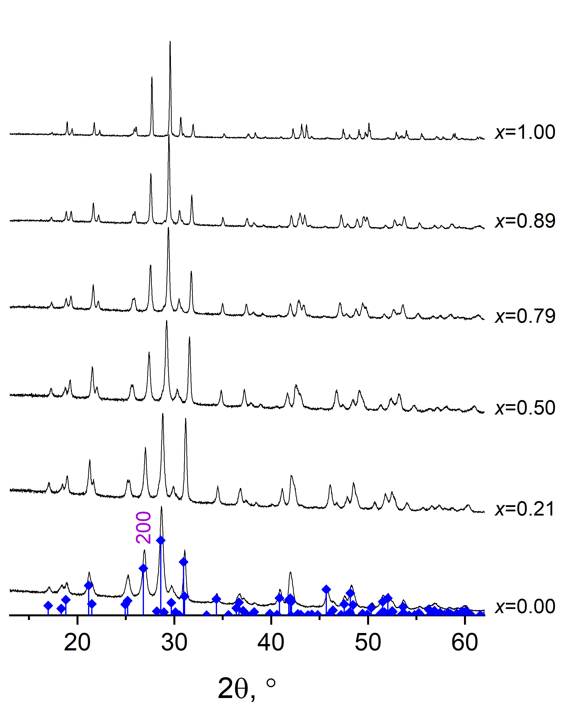
Figure S3. Diffraction patterns of samples in the La_{1-x}Gd_{x}PO₄ system with structure of
monazite, obtained using hydrothermal treatment at 230°C for 5 days of isothermal holding. The vertical lines correspond to the phase with the monazite structure.
Таблица S2. Thermal analysis data for samples obtained by precipitation, where ΔT, °C is the temperature range of mass change; n is the number of water molecules in the structure of rhabdophane (La_{1-x}Gd_{x}PO₄·nH₂O), T_{onset},°C is the temperature of the onset of the exothermic effect associated with the structural transformation rhabdophane → monazite.
Sample | Step | ΔТ, °С | n |  | T_{onset}, °С
x=0.00 | 1 | 130-201 | 0.25 | 0.97 | 601
x=0.00 | 2 | 201-295 | 0.46 | 0.97 | 601
x=0.00 | 3 | 295-800 | 0.26 | 0.97 | 601
x=0.20 | 1 | 123-190 | 0.29 | 1.01 | 662
x=0.20 | 2 | 190-274 | 0.48 | 1.01 | 662
x=0.20 | 3 | 274-800 | 0.24 | 1.01 | 662
x=0.48 | 1 | 130-183 | 0.25 | 0.95 | 701
x=0.48 | 2 | 183-270 | 0.49 | 0.95 | 701
x=0.48 | 3 | 270-800 | 0.21 | 0.95 | 701
x=0.76 | 1 | 123-178 | 0.21 | 0.86 | 728
x=0.76 | 2 | 178-257 | 0.48 | 0.86 | 728
x=0.76 | 3 | 257-800 | 0.17 | 0.86 | 728
x=0.85 | 1 | 122-180 | 0.20 | 0.89 | 734
x=0.85 | 2 | 180-247 | 0.47 | 0.89 | 734
x=0.85 | 3 | 24-800 | 0.22 | 0.89 | 734
x=1.00 | 1 | 114-158 | 0.16 | 0.82 | 733
x=1.00 | 2 | 158-225 | 0.44 | 0.82 | 733
x=1.00 | 3 | 225-800 | 0.26 | 0.82 | 733

