Supplementary Information
Granular Ni-Mo-W bulk hydrotreating catalyst: the effects from precursor calcination

K. A. Nadeina, Yu. V. Vatutina, P. P. Mukhacheva, S. V. Budukva, I. G. Danilova, V. P. Pakharukova, E. Yu. Gerasimov, M. A. Panafidin, O. V. Klimov
Boreskov Institute of Catalysis SB RAS, Lavrentiev Ave. 5, Novosibirsk, Russia, 630090

* Corresponding author.
E-mail address: : lakmallow@catalysis.ru (K.A. Nadeina)

Figure SI1 – XRD data of granulated catalyst with different precursor calcination temperature and catalysts calcination temperature
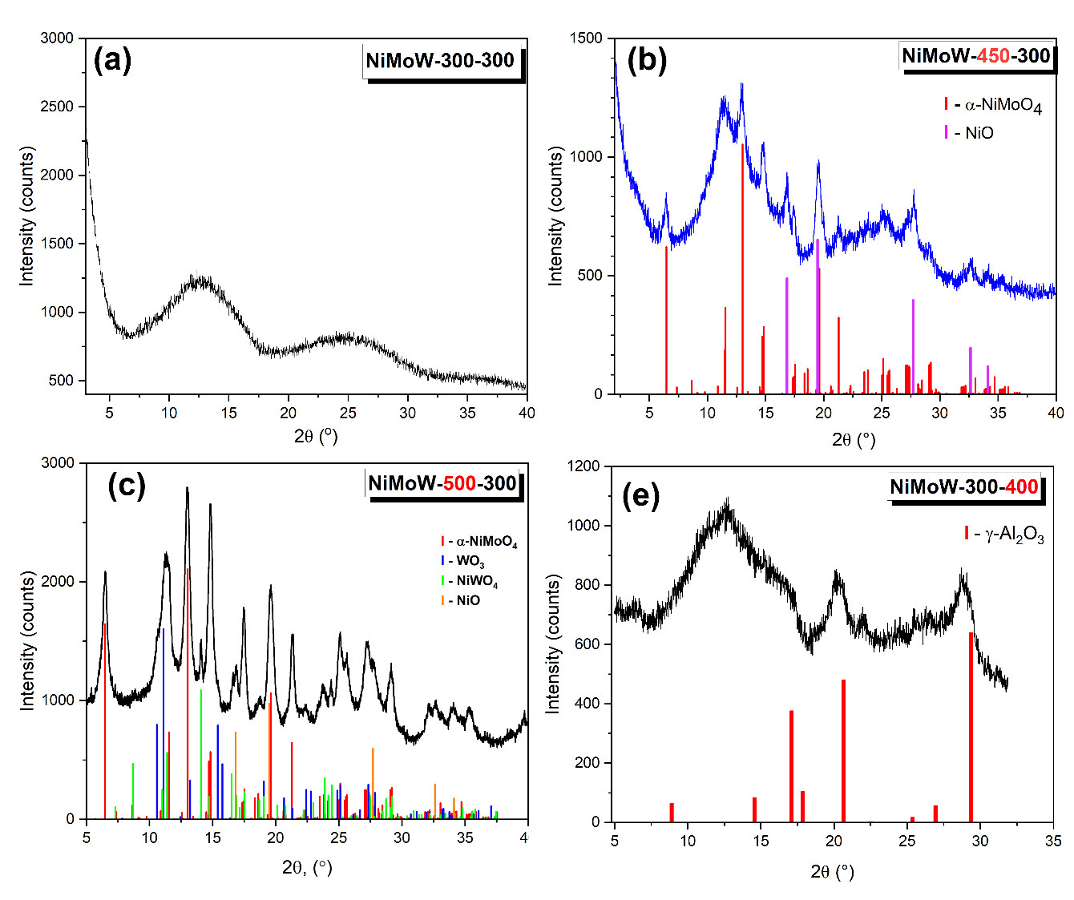
Figure SI2 – Nitrogen adsorption-desorption isotherms and pore size distribution curves for granulated calcined catalysts
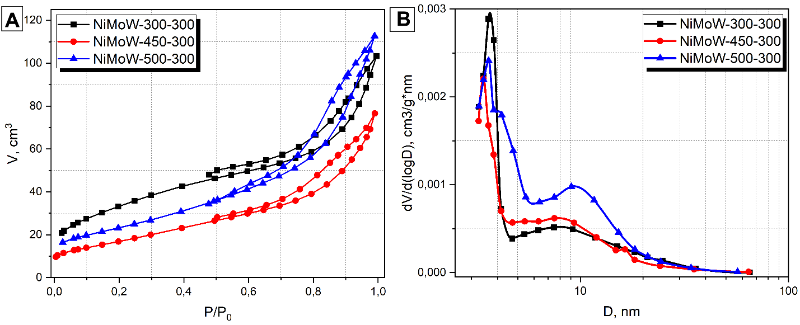

Figure SI3 — Pore size distribution curves for sulfided catalysts after reaction
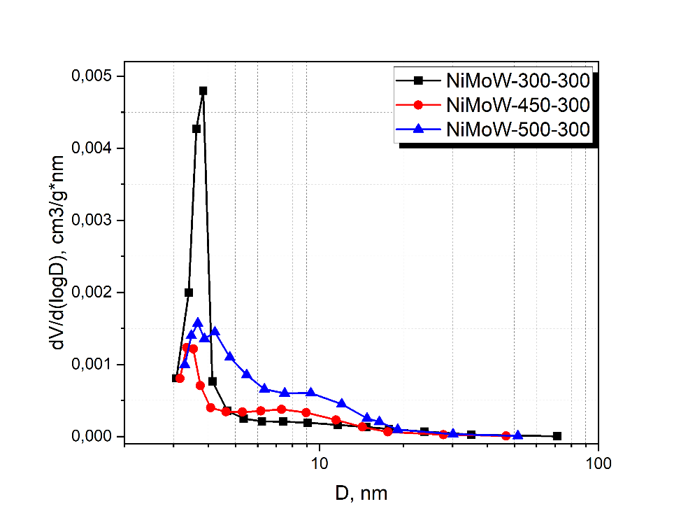

Figure SI4 – HAADF data on the NiMoW-450-300 catalyst before testing
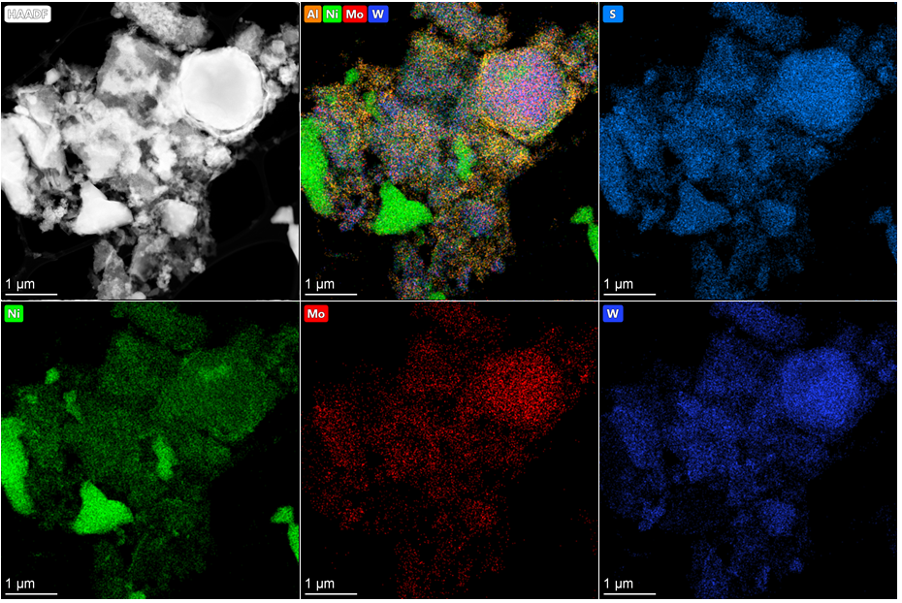

Figure SI5 – HAADF data on the NiMoW-500-300 catalyst before testing
