TiO2 nanotubes modified with cadmium oxide for photoelectrocatalytic oxidation of alcohols

**Vitali Grinberg** ˑ **Victor Emets** ˑ **Alexey Shapagin** ˑ **Aleksey Averin** ˑ **Andrei Shiryaev**

Frumkin Institute of Physical Chemistry and Electrochemistry, Russian Academy of Sciences, Leninsky Prospekt 31, Building 4, 119071 Moscow, Russia

* Correspondence: [victoremets@mail.ru](mailto:victoremets@mail.ru); Tel.: +7(495) 955-40-23

**Supplementary materials**

0.05 C

ZAF Method Standardless Quantitative Analysis

Fitting Coefficient : 0.2626

Element (keV) mass% Error% At% Compound mass% Cation K

C K 0.277 1.97 0.05 4.73 1.2149

O K 0.525 30.27 0.47 54.57 12.6515

Ti K 4.508 67.46 0.34 40.63 85.7918

Cd L* 3.132 0.30 0.47 0.08 0.3418

Total 100.00 100.00

ZAF Method Standardless Quantitative Analysis

Fitting Coefficient : 0.2679

Element (keV) mass% Error% At% Compound mass% Cation K

C K 0.277 2.17 0.05 5.02 1.3691

O K 0.525 33.10 0.43 57.51 14.6929

Ti K 4.508 64.45 0.33 37.40 83.6111

Cd L* 3.132 0.28 0.46 0.07 0.3269

Total 100.00 100.00

0.2 C

ZAF Method Standardless Quantitative Analysis

Fitting Coefficient : 0.2617

Element (keV) mass% Error% At% Compound mass% Cation K

C K 0.277 1.62 0.05 3.91 1.0134

O K 0.525 30.89 0.45 55.88 13.1659

Ti K 4.508 65.86 0.33 39.79 83.9665

Cd L 3.132 1.62 0.46 0.42 1.8542

Total 100.00 100.00

0.8 С

1/1

**1058Fig. S1.** Duration of the first and second anodization step – 60 min followed by cathodic deposition of varying amounts of cadmium oxide 0,05, 0,2 and 0,8 C correspondingly and Standardless Quantitative Analysis.

1/1

1/1

(a)

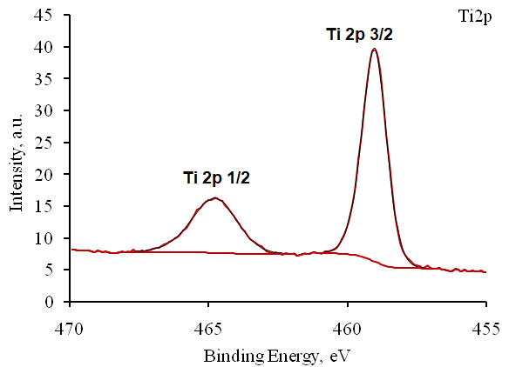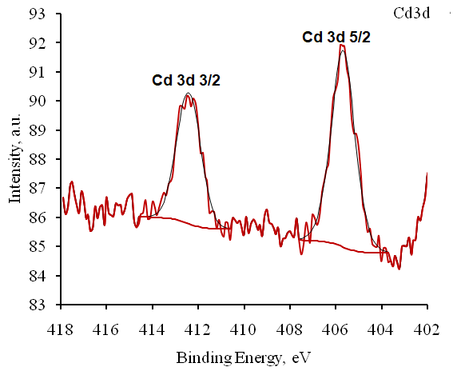(b) (c)

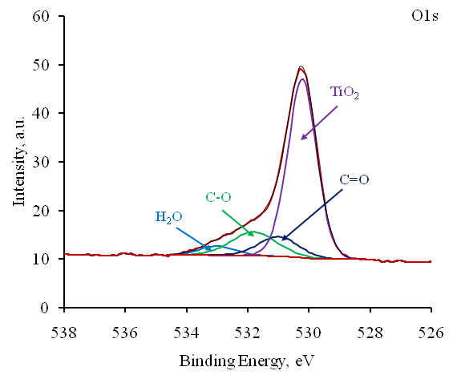 (d)

|  |  |  |  |  |
| --- | --- | --- | --- | --- |
|  |  |  |  |  |
| Peak name | | Eb, eV | Quant., at.% | |
| Ti2p | TiO2 | 459 | 25,95 | 25,95 |
| Cd3d | Cd | 405,6 | 0,12 | 0,12 |
| O1s | H2O | 533 | 3,36 | 73,93 |
| C-O | 531,8 | 10,81 |
| C=O | 531 | 7,9 |
| TiO2 | 530,2 | 51,86 |
|  |  |  |  |  |

**Fig. S2.** XPS spectra of cadmium-modified TiO2-NTbs prepared by cathodic deposition of CdО (0.2 C/cm2) (a) High-resolution XPS spectra of Ti 2p, Cd 3d and O 1s(b-d). The sample was calcined at 450 °C in air for 1 h.

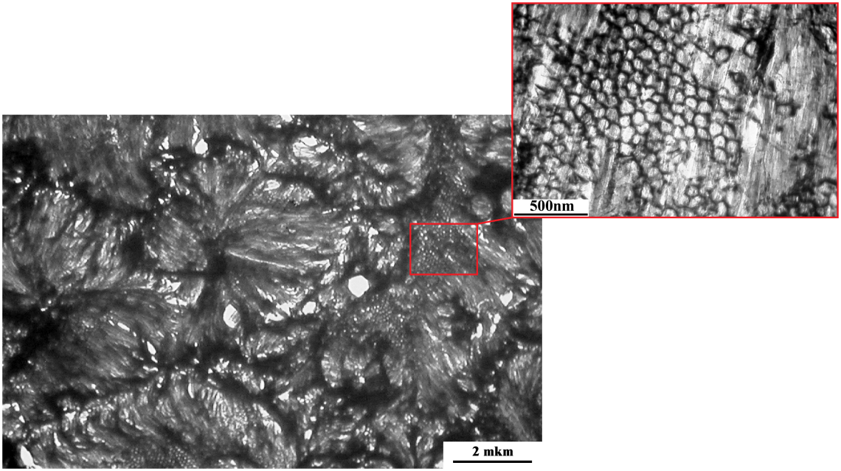

**Fig. S3.** TEM image of the supermolecular surface structure of TNT – (0.2)CdO.

Fig. 8.tif

**Fig. S4.** Wavelength dependence ofIPCE% for the TNT and TNT–(0.05)CdO photoanodes in 0.1 M Na2SO4 aqueous solution.