ELECTRONIC SUPPORTING INFORMATION (ESI)
Isomeric Protected Dipeptides Generated Stable Bio-compatible Gold Nanoparticles

Sudeshna Kar^{a,b}* and Yian Tai^{b}*

ªAssistant Professor, Department of Basic Science and Humanities (Chemistry), St. Thomas College of Engineering and Technology, 4, Diamond Harbour Rd, Alipore Body Guard Lines, Khidirpur, Kolkata, West Bengal 700023, Kolkata, India

^{b}National Taiwan University of Science and Technology, 43 Keelung Road, Taipei-106, Taiwan

*Corresponding author, E-mail: 06.sudeshna@gmail.com; ytai@mail.ntust.edu.tw

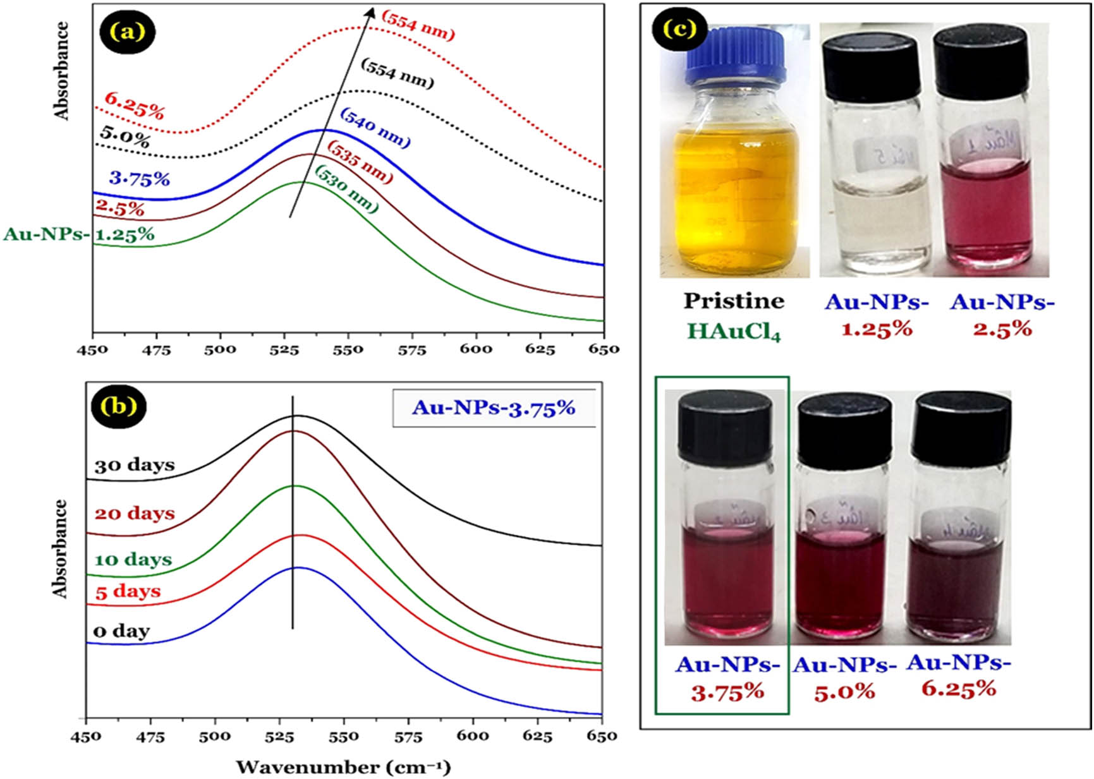
Peptide I bound AuNPs Peptide II bound AuNPs
Figure S1: The color of the newly synthesized AuNPs solutions.

Table S1: Experimental parameters of Zeta potential study.
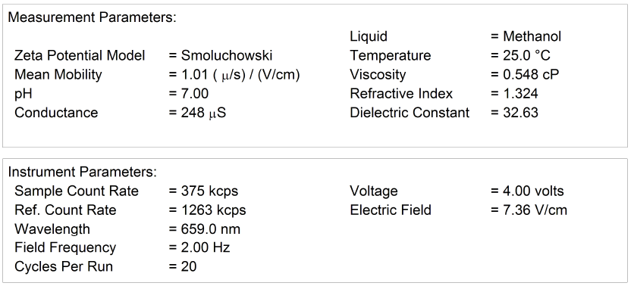

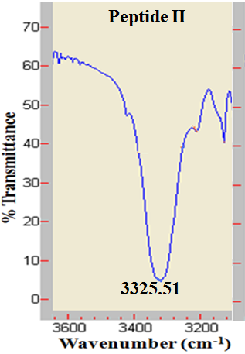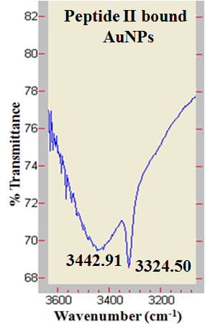
Figure S2 FT-IR spectra of peptide II and peptide II bound gold nano-particles (AuNPs) in solid state (3200-3600 cm⁻¹ range).

Figure S3 FT-IR spectra of peptide II and peptide II bound gold nano-particles (AuNPs) in solid state (1640-1760 cm⁻¹ range).

Figure S4 ¹H NMR spectrum of peptide II in DMSO-D6 (500 MHz) (7-10 ppm region).

Figure S5 ¹H NMR spectrum of peptide I bound AuNPs in DMSO-D6 (500 MHz) (7-10 ppm region).

Figure S6 ¹H NMR spectrum of peptide II in DMSO-D6 (500 MHz) (1-4 ppm region).

Figure S7 ¹H NMR spectrum of peptide II bound AuNPs in DMSO-D6 (500 MHz) (1-4 ppm region).

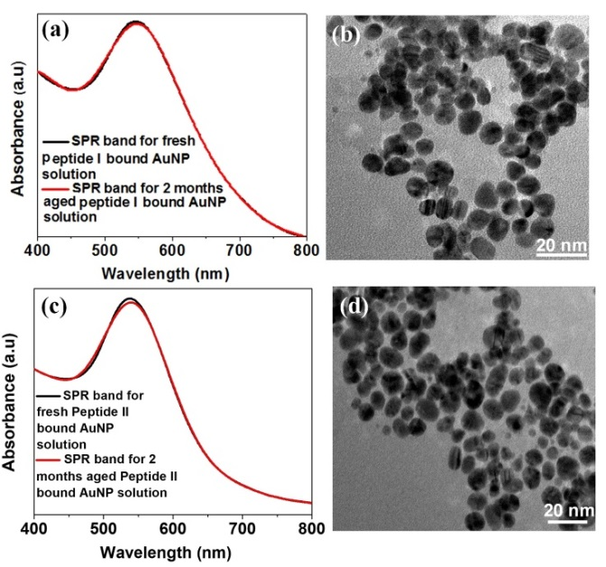
Figure S8 (a) surface plasmon resonance band for freshly prepared peptide I bound AuNP solution and 2 months aged peptide I/AuNP solution are shown in the UV spectrum; (b) TEM image of 2 months aged peptide I/AuNP; (c) surface plasmon resonance band for freshly prepared peptide II bound AuNP solution and 2 months aged peptide II/AuNP solution are shown in the UV spectrum; (d) TEM image of 2 months aged peptide II/AuNP

Table S2. Statistical results of MTT test
Sample | Control | Peptide I | Peptide II | Peptide I  AuNP | Peptide II  AuNP
Day 1 | 0.067 ±  0.002 | 0.082 ±  0.005 | 0.078 ±  0.006 | 0.075 ±  0.008 | 0.065 ±  0.007
Day 3 | 0.068 ±  0.003 | 0.065 ±  0.003 | 0.066 ±  0.007 | 0.075 ±  0.014 | 0.065 ±  0.002
Day 5 | 0.068 ±  0.010 | 0.066 ±  0.008 | 0.077 ±  0.005 | 0.08 ±  0.005 | 0.067 ±  0.013

